Section 21: Network – VPC

AWS Solution Architect Associate

# Abbreviations

1. CIDR – Classless Inter-Domain Routing
2. IANA – Internet Assigned Number Authority
3. VPC – Virtual Private Cloud
4. NAT – Network Address Translation

# 238. CIDR, Private Vs Public IP

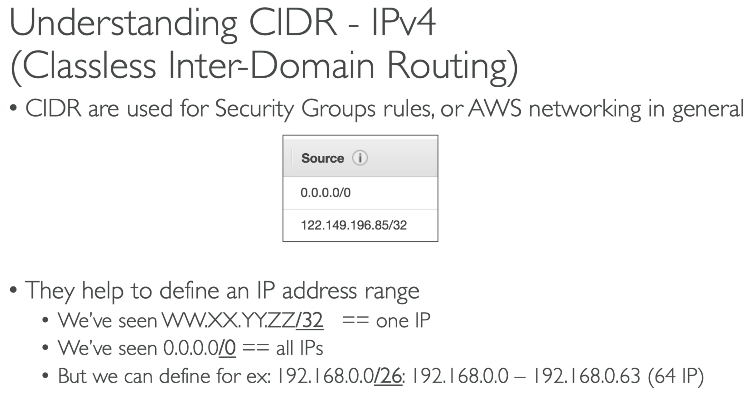

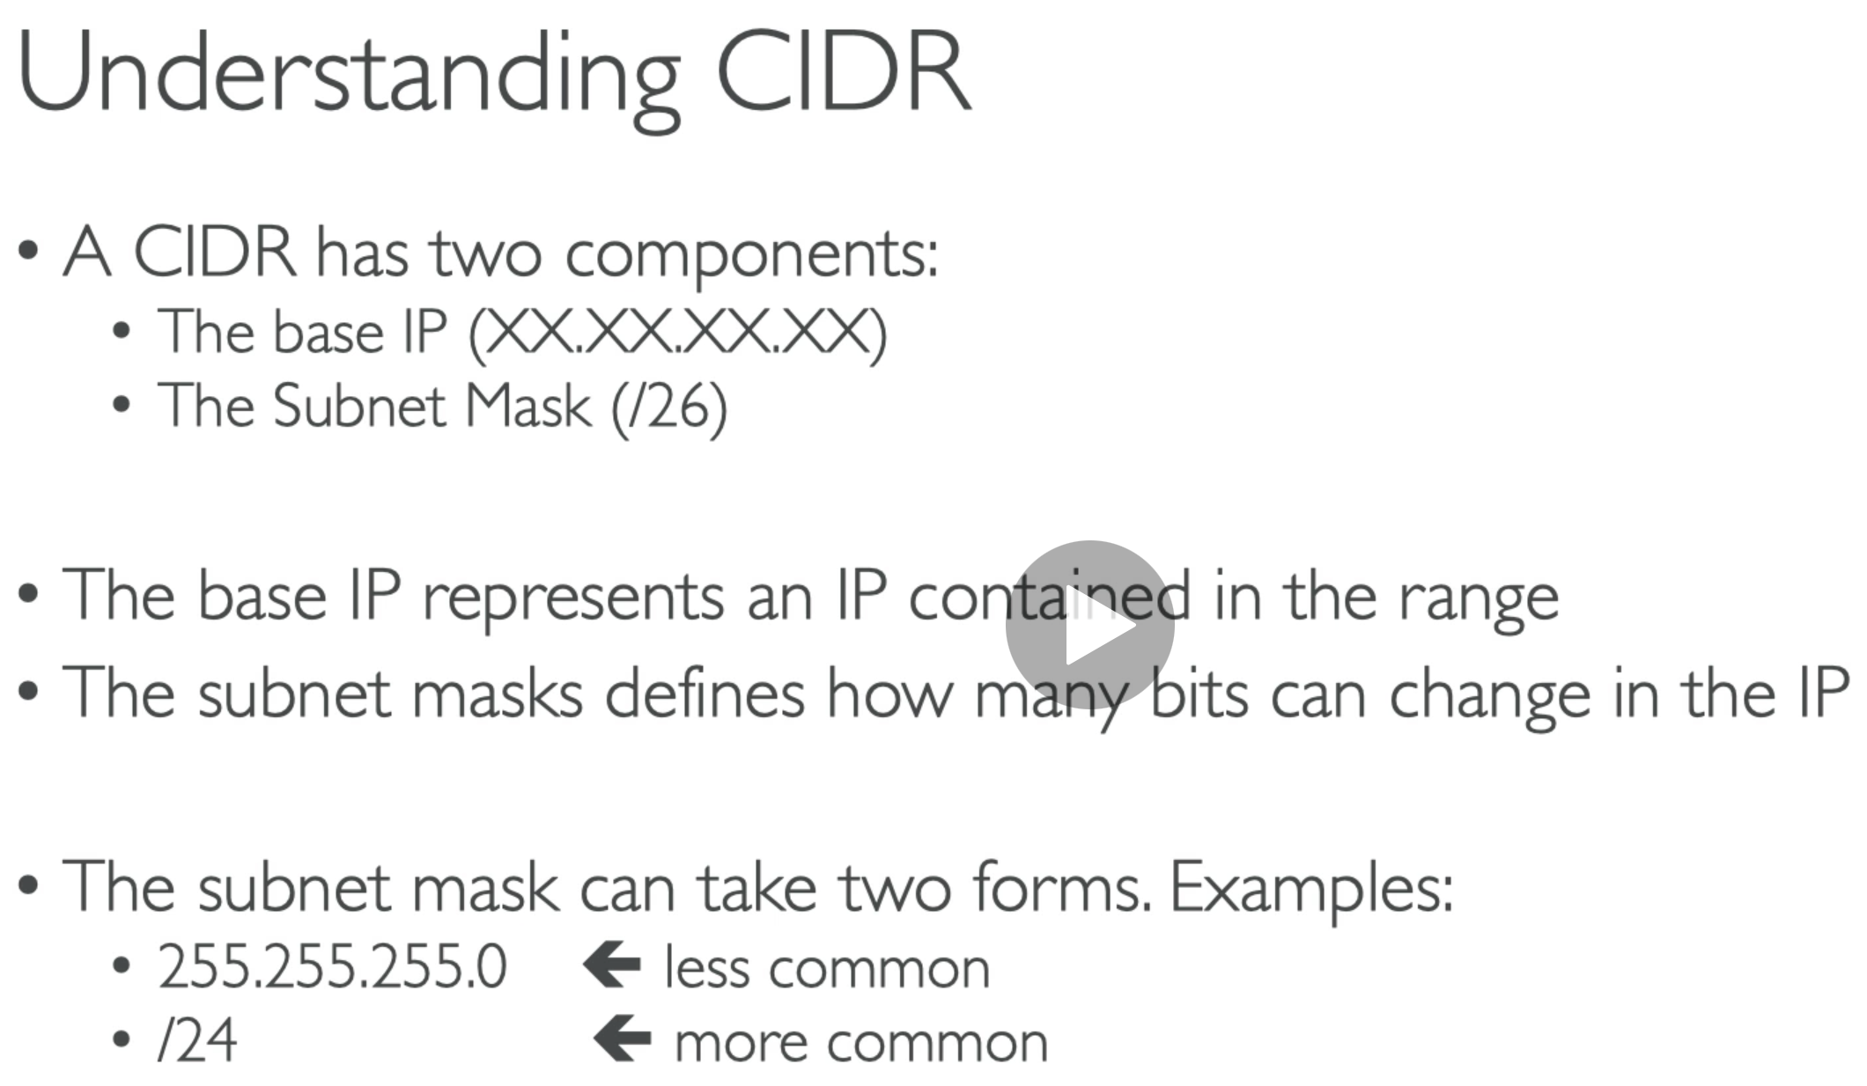

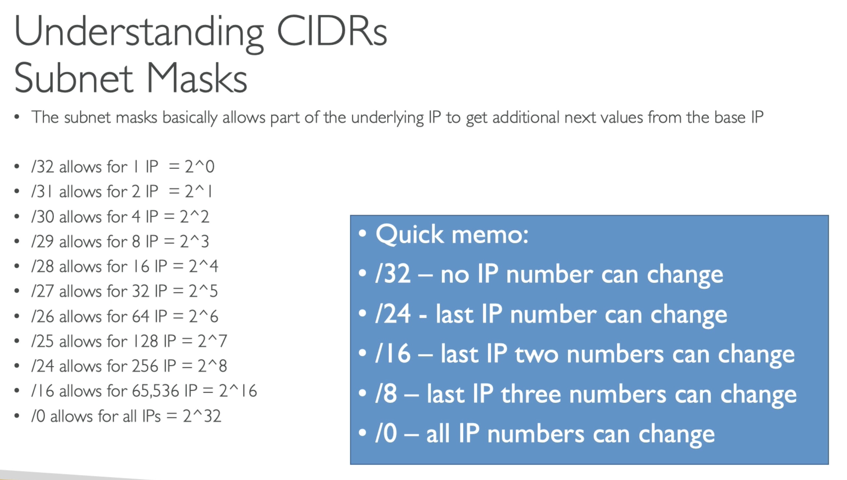

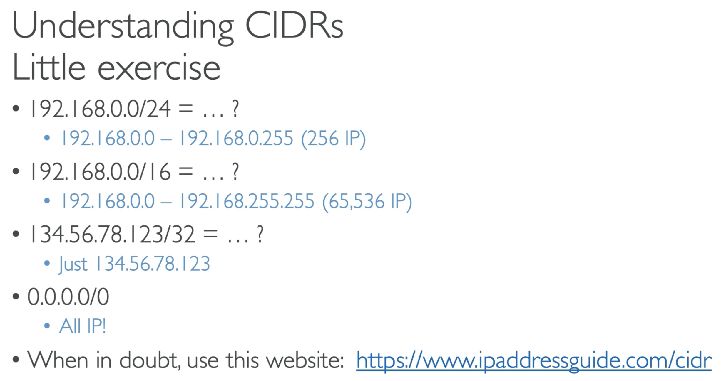

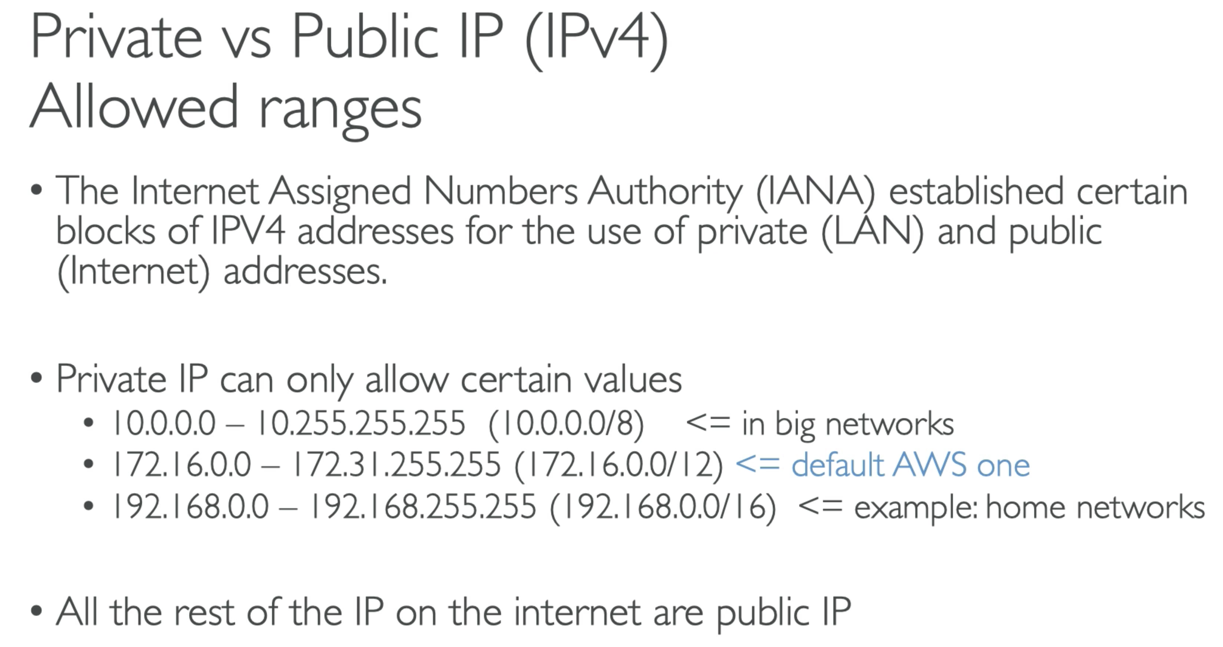

# 239. Default VPC Overview

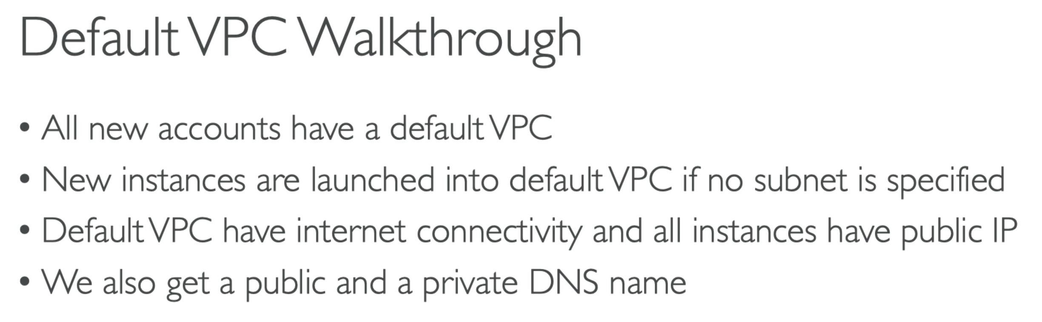

With default VPC, you also get 3+ subnets, 1 route table, 1 internet gateway, and 1 network ACL that allows all inbound and all out bound rules.

# 240. VPC Overview – Hands On

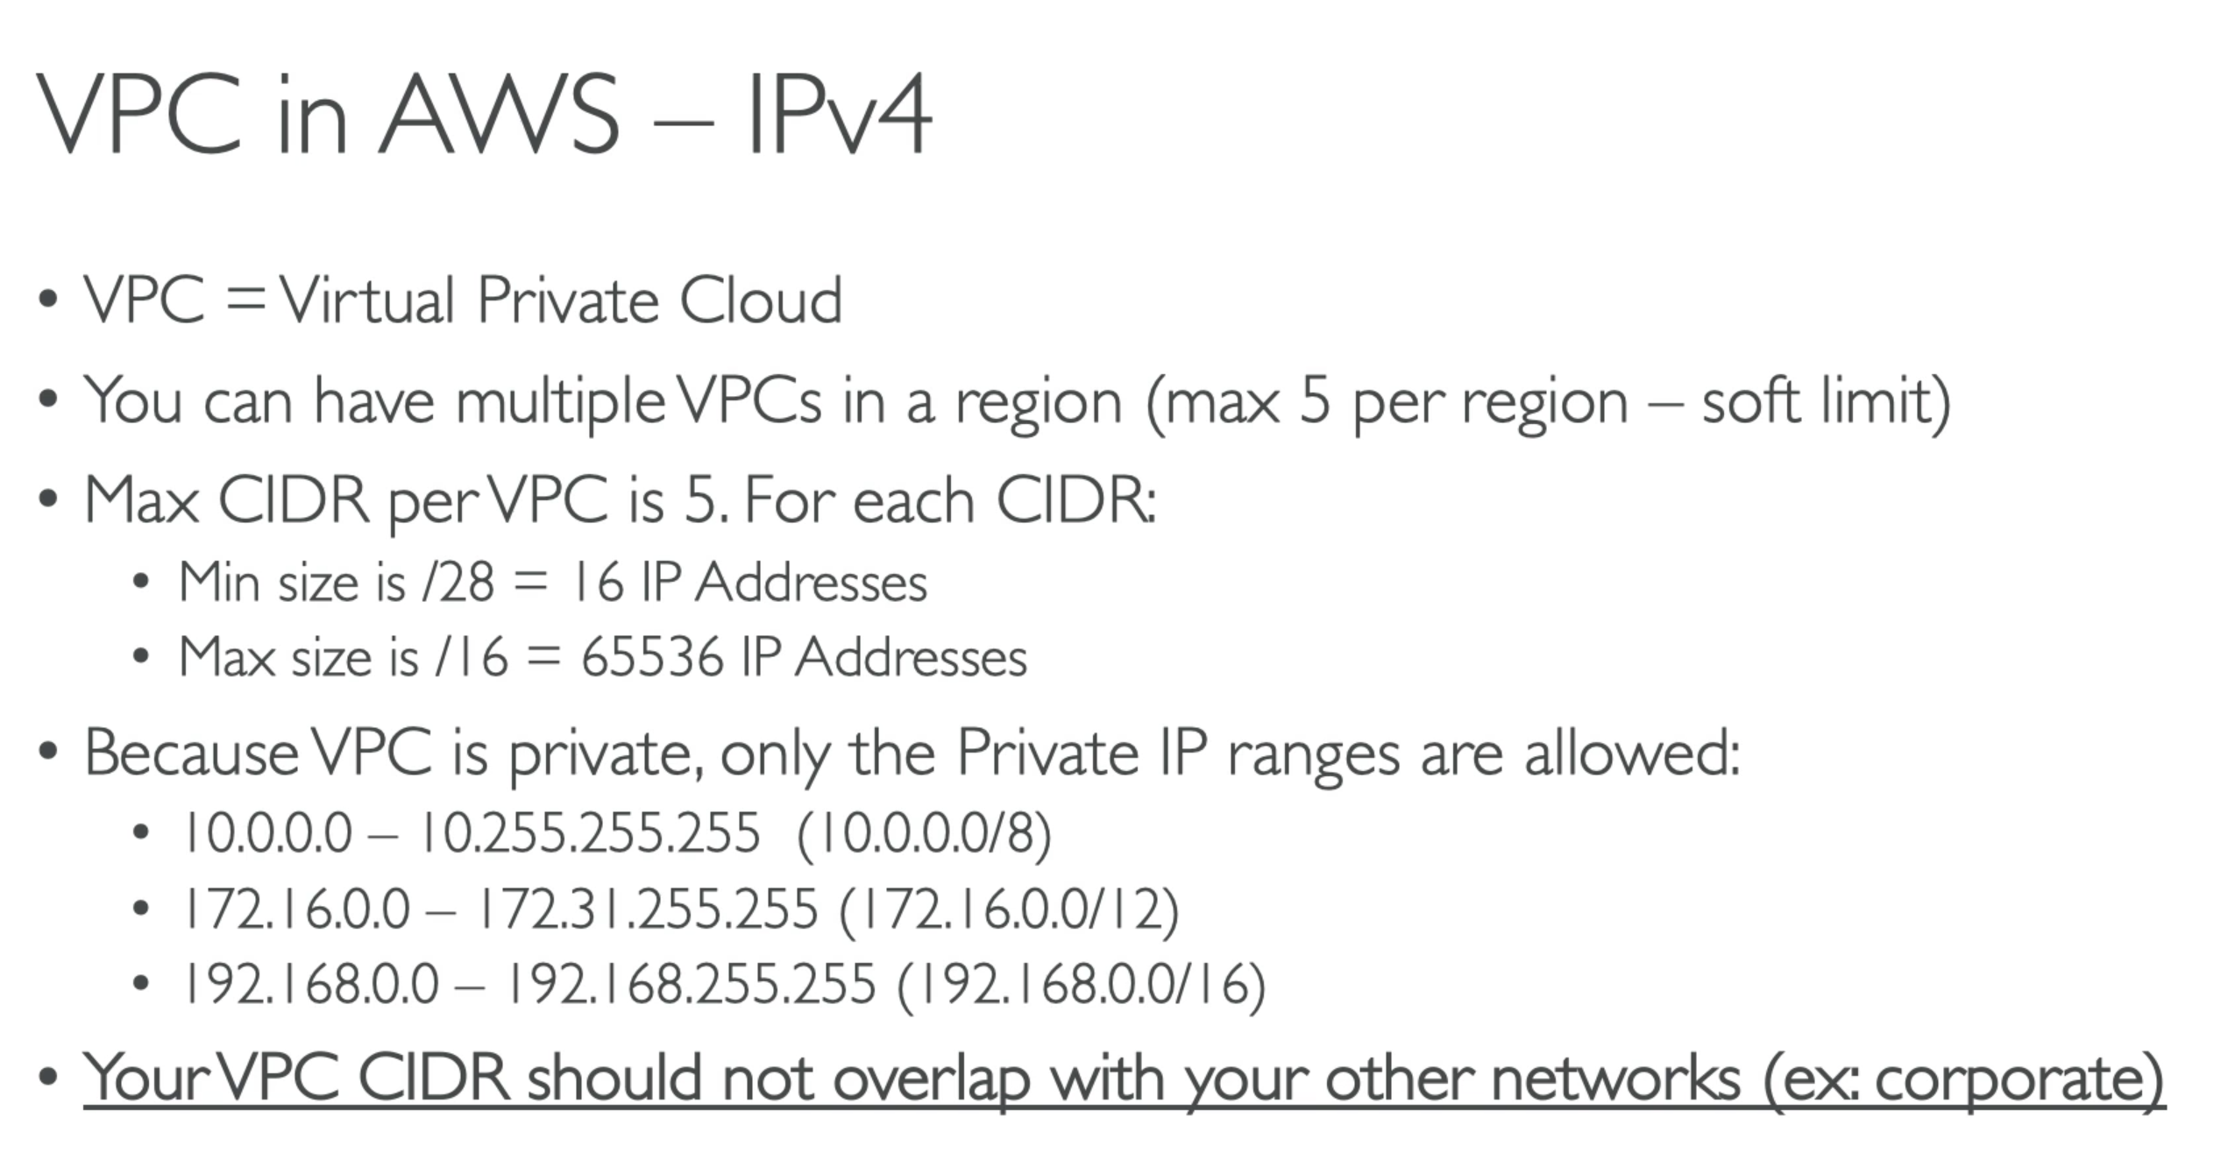

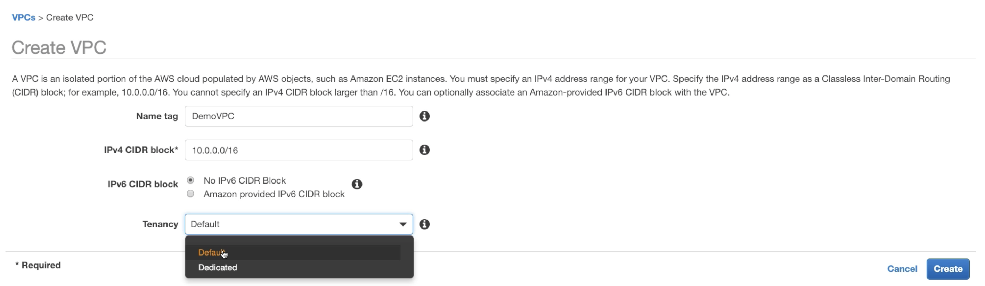

# 241. Subnet Overview and Hands On

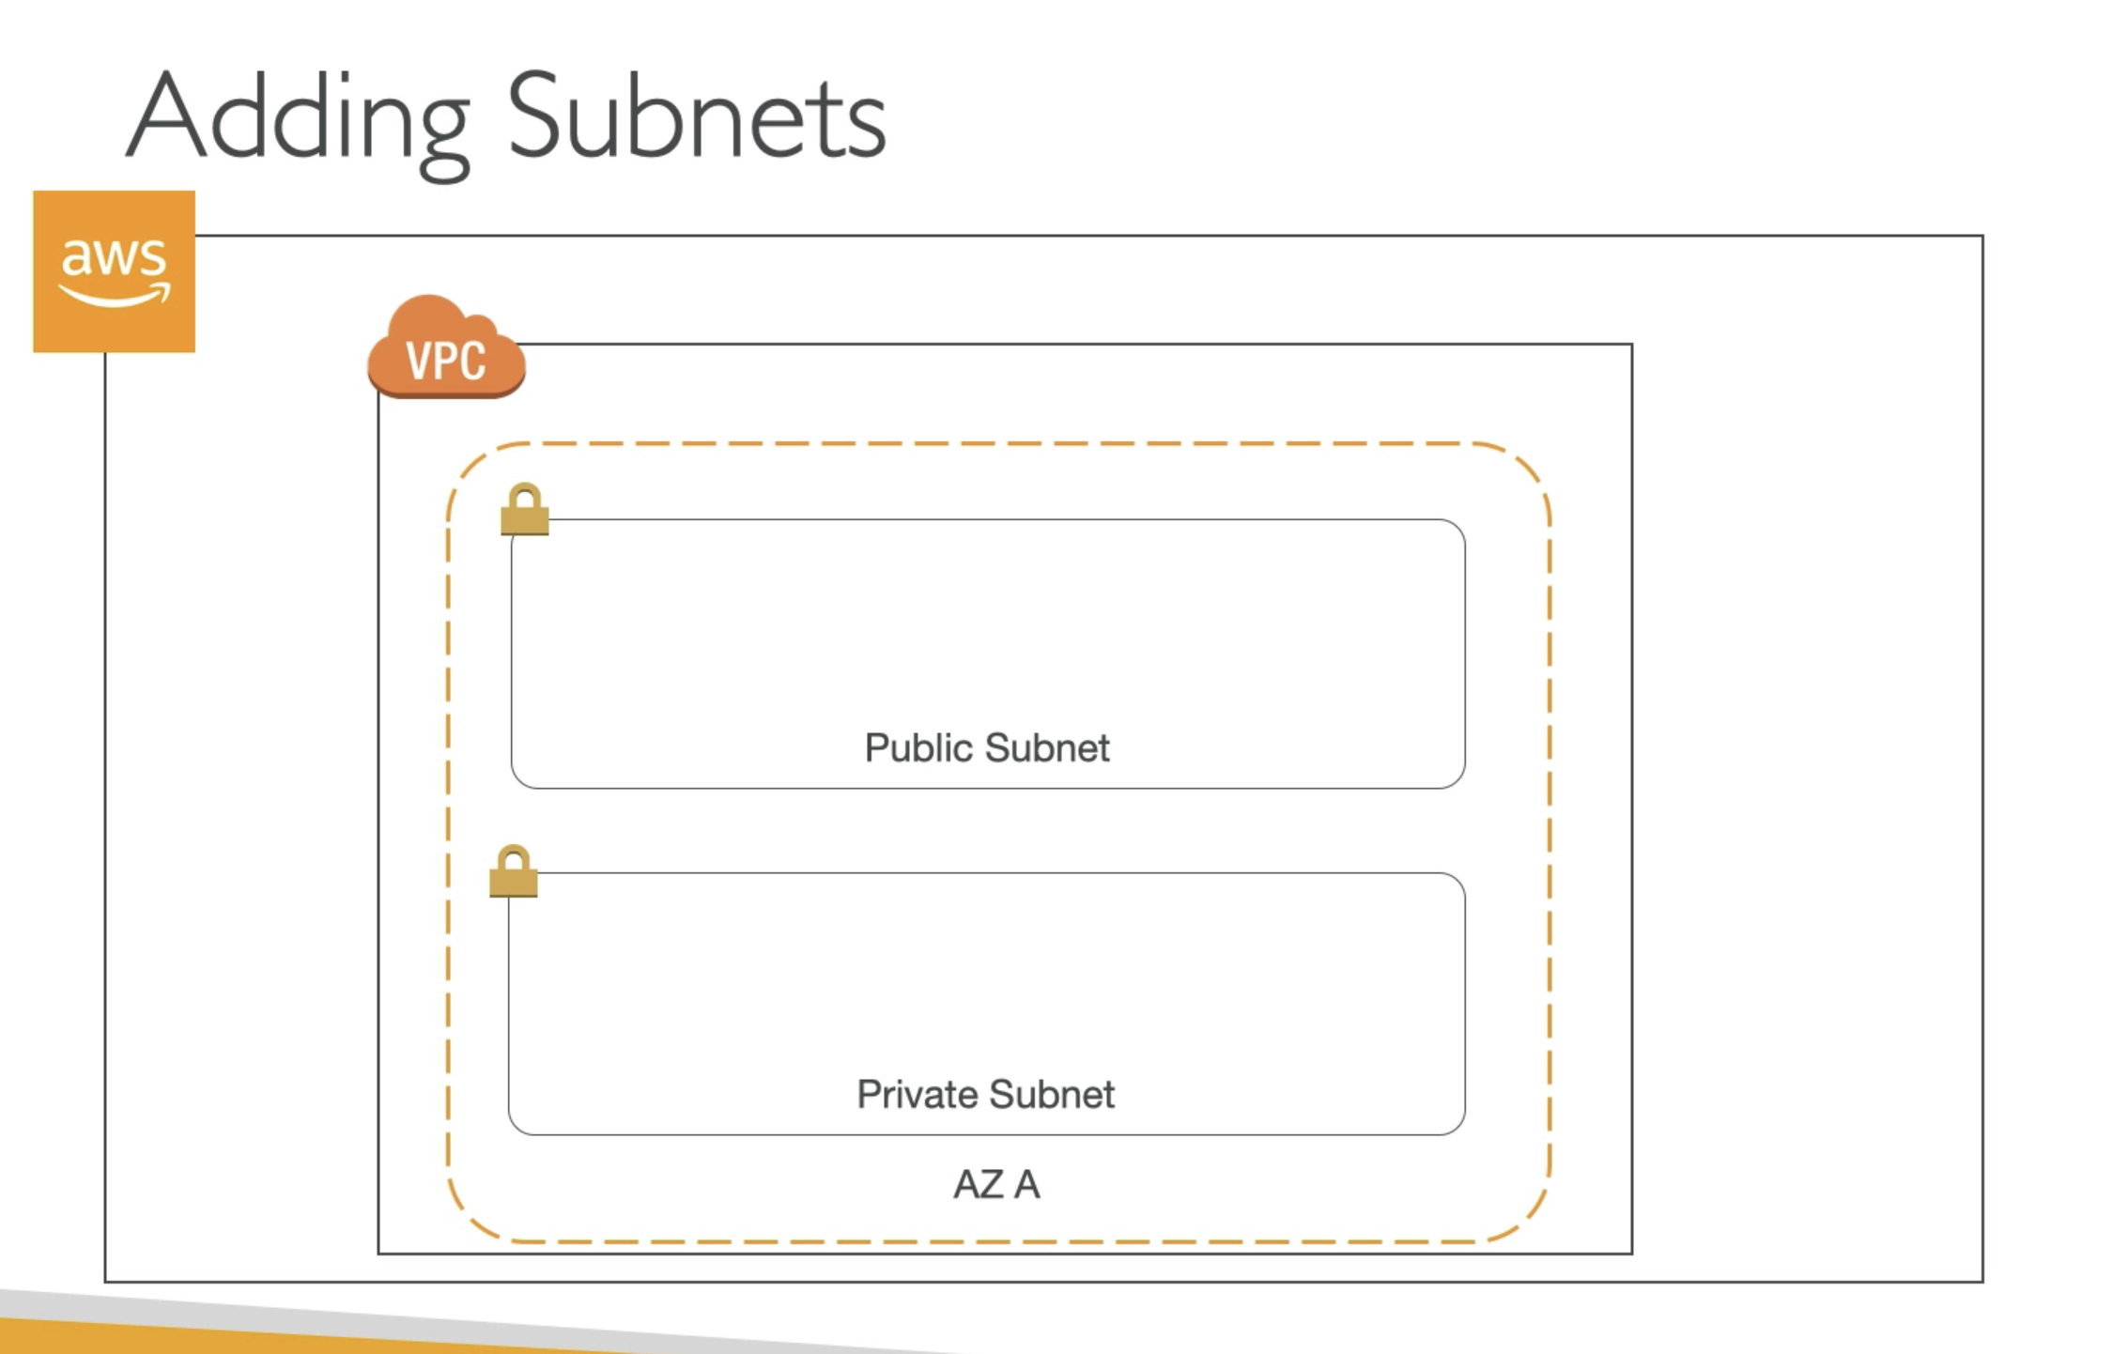

* We will create 2 subnet per AZ, which will be total 4 subnet. Some of them are private and some are public.
* Usually public subnet is much smaller than the private subnet. Because on public subnet we only put our Load Balancers, where as in private subnet we put all the applications etc.

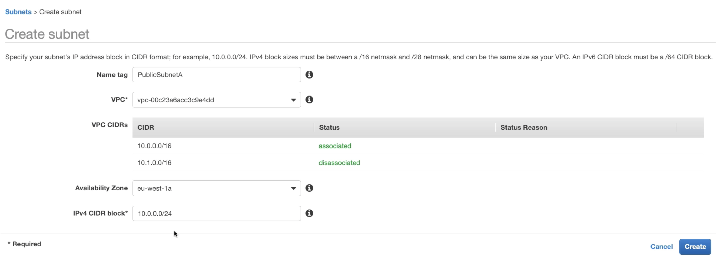

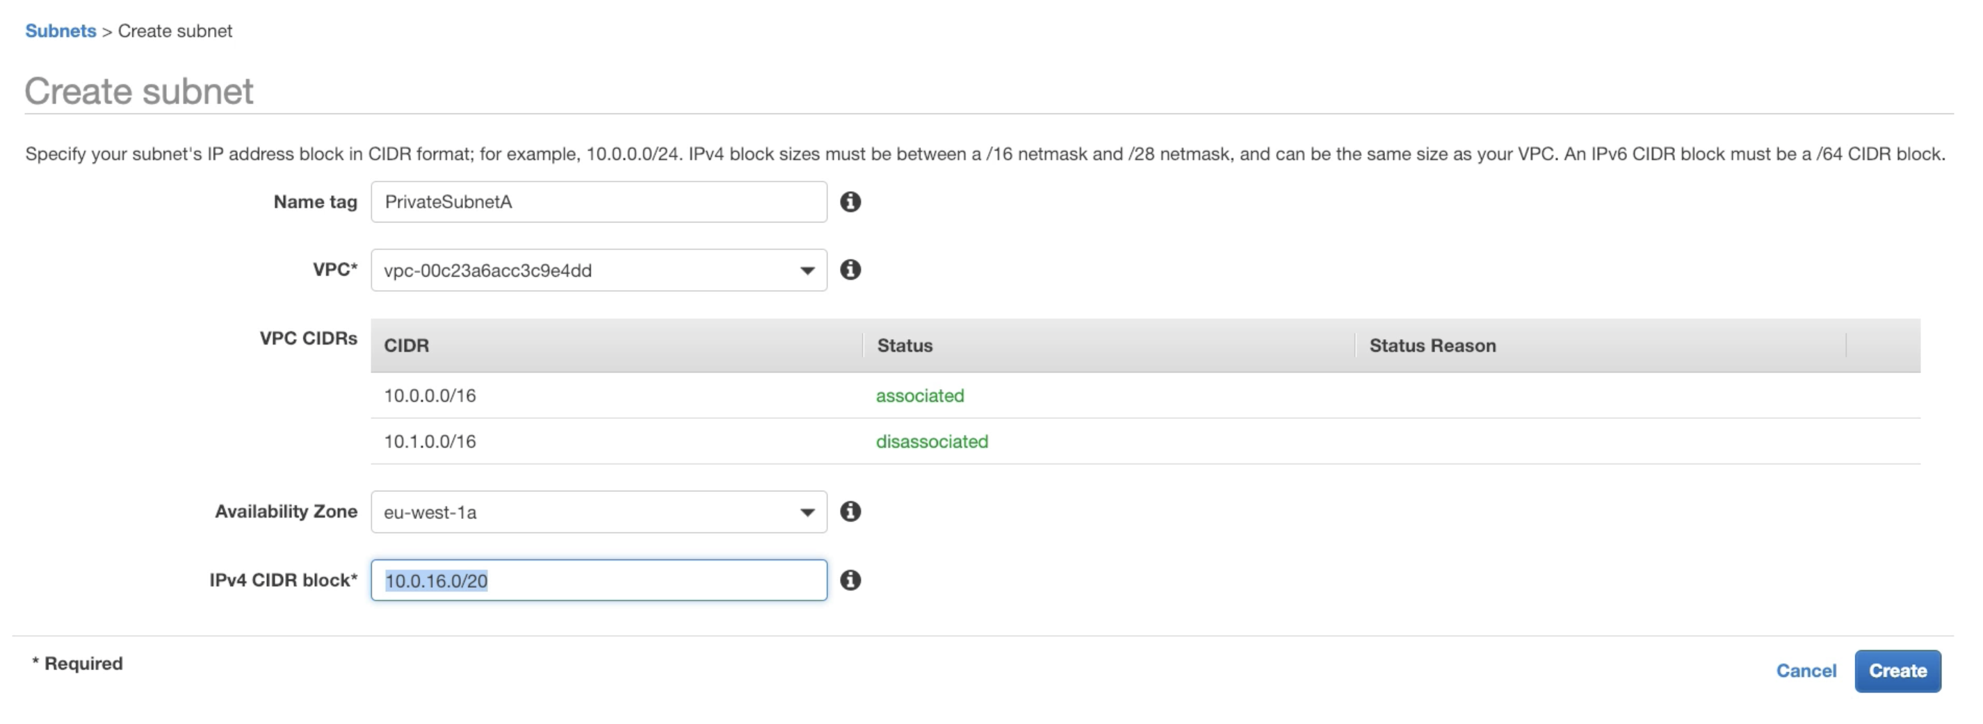

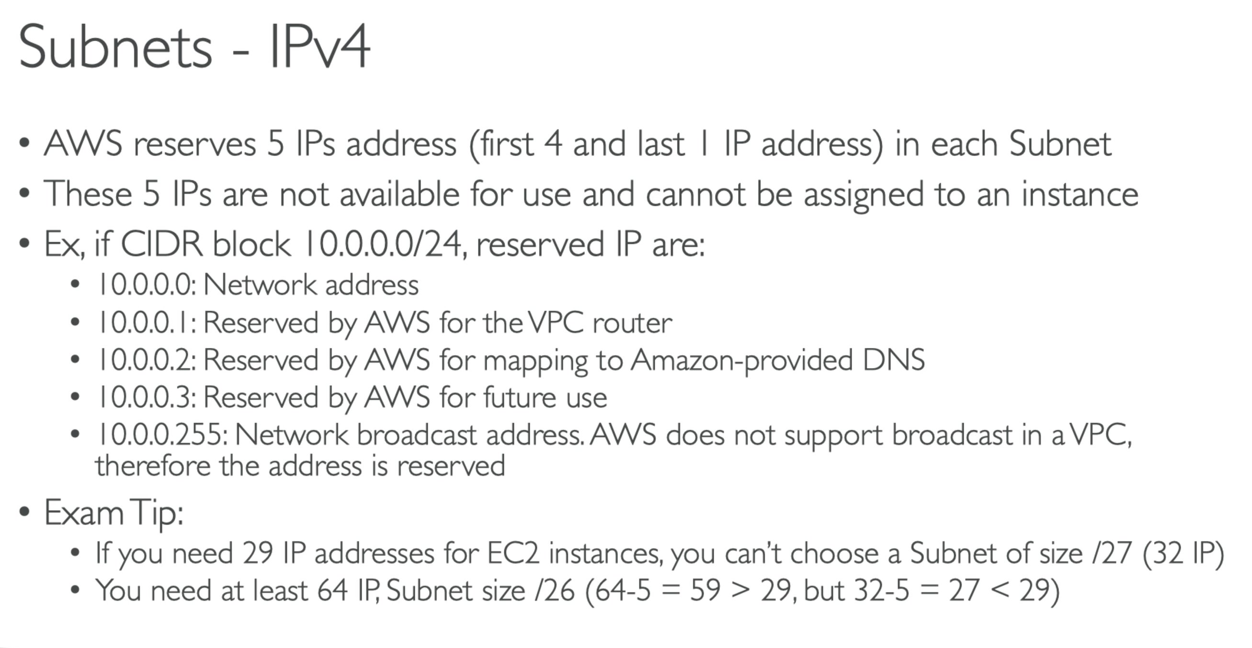

# 242. Internet Gateway and Route Tables

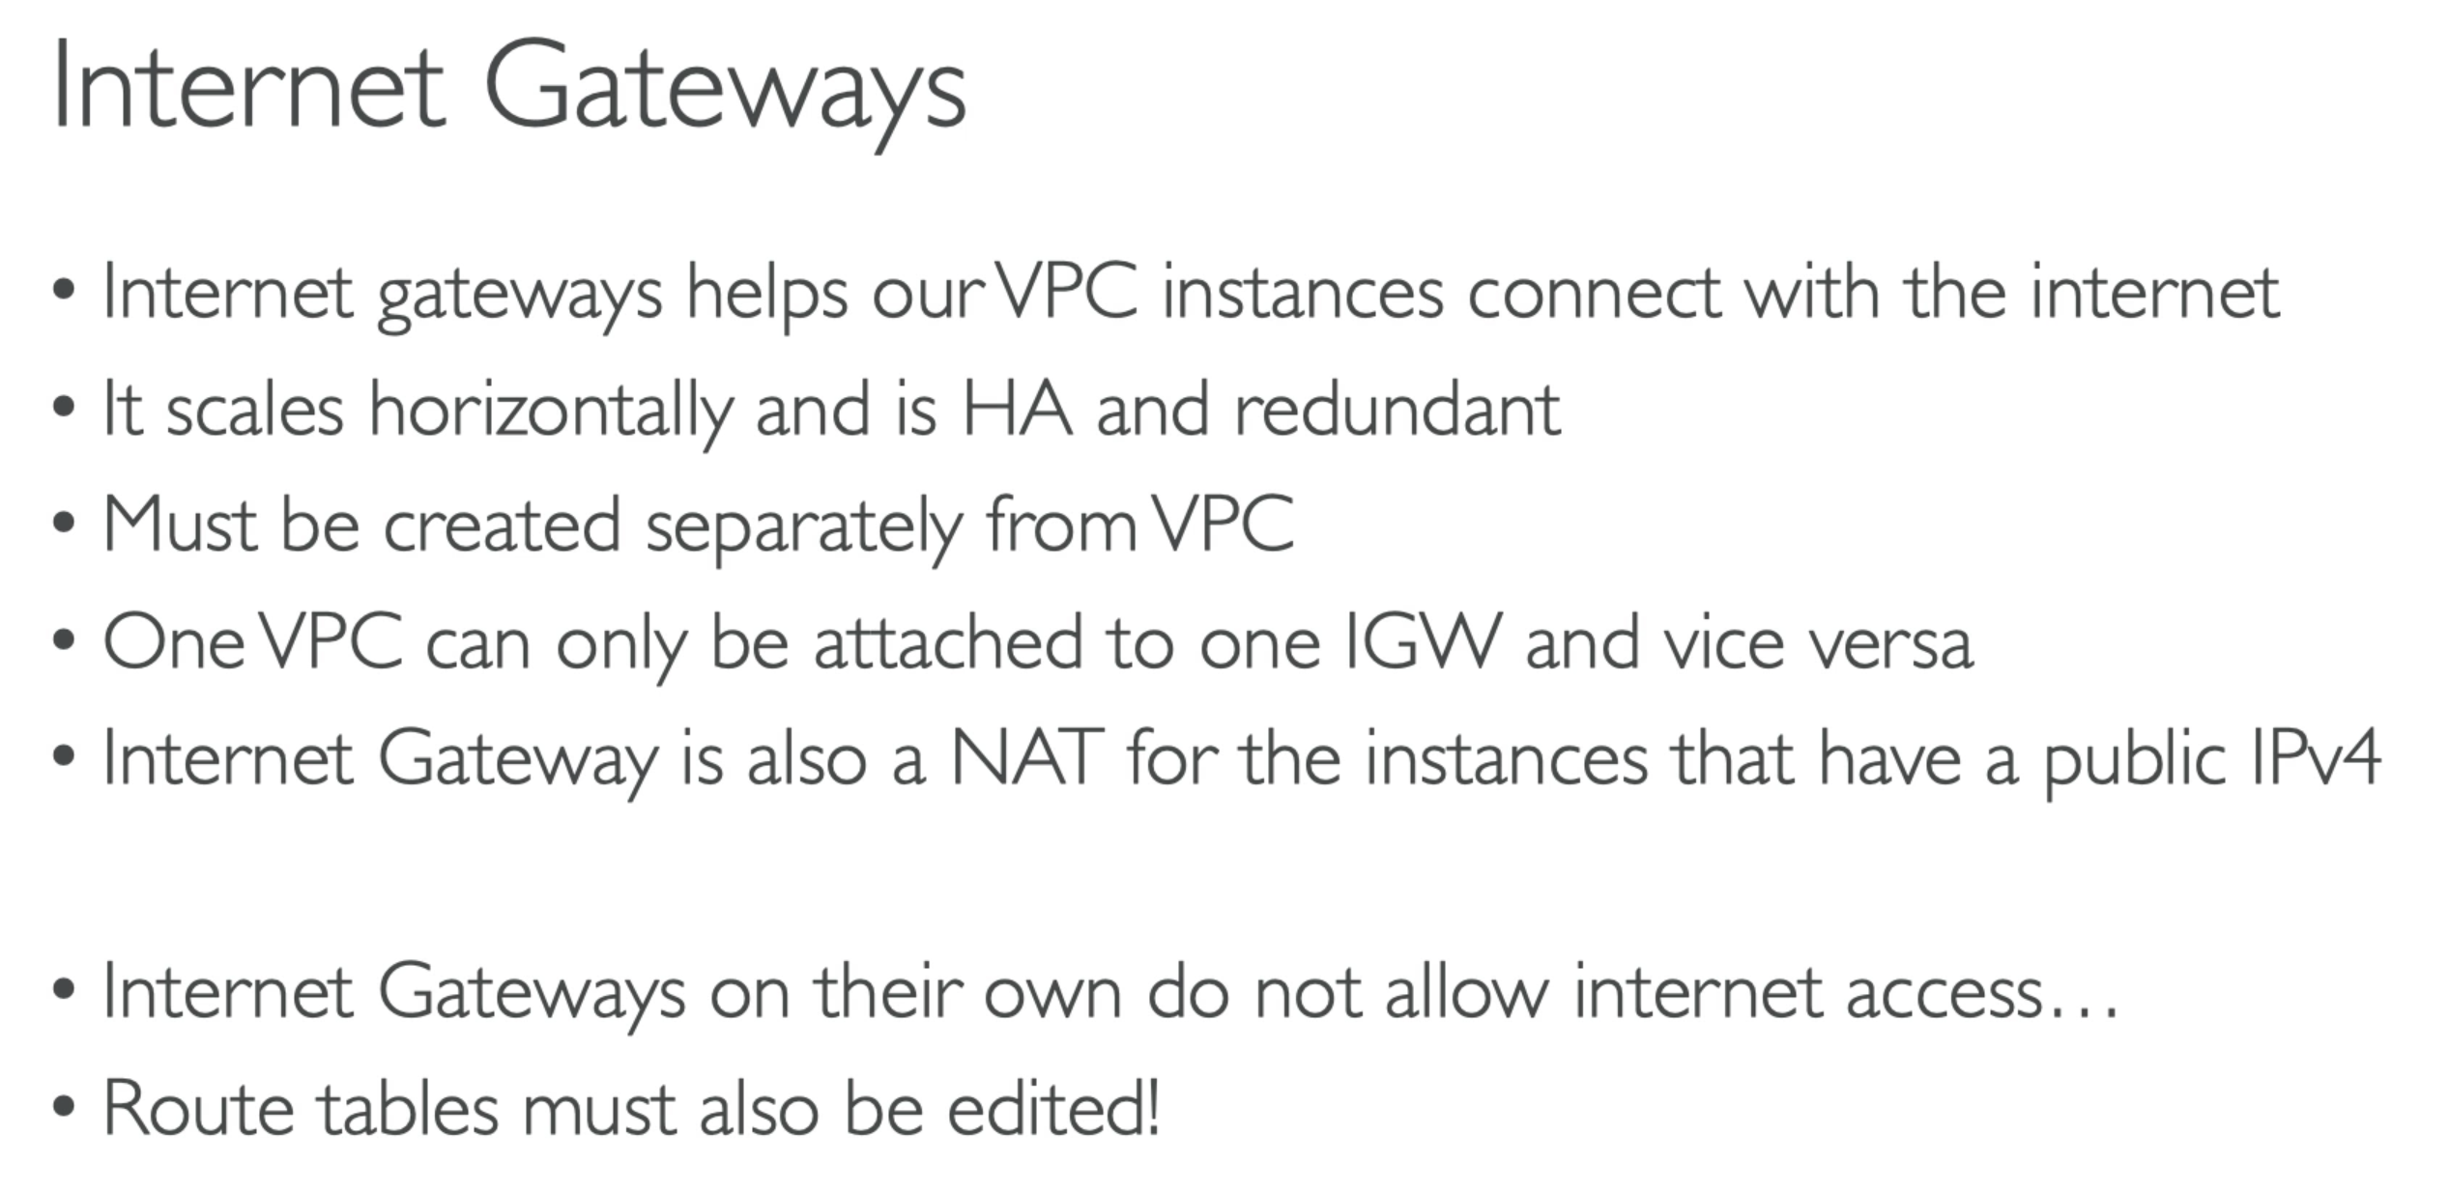

**Exam Tip:**   
One IGW per VPC is a common exam question. If you try to create another IGW and attach it with the VPC, it will simply not work.

## Create IGW:

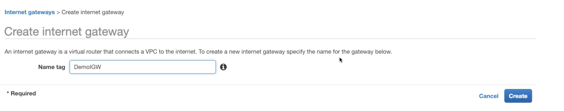

## Attach IGW to VPC

* Right click on IGW and click on Attach to VPC
* Select the VPC and click on Attach

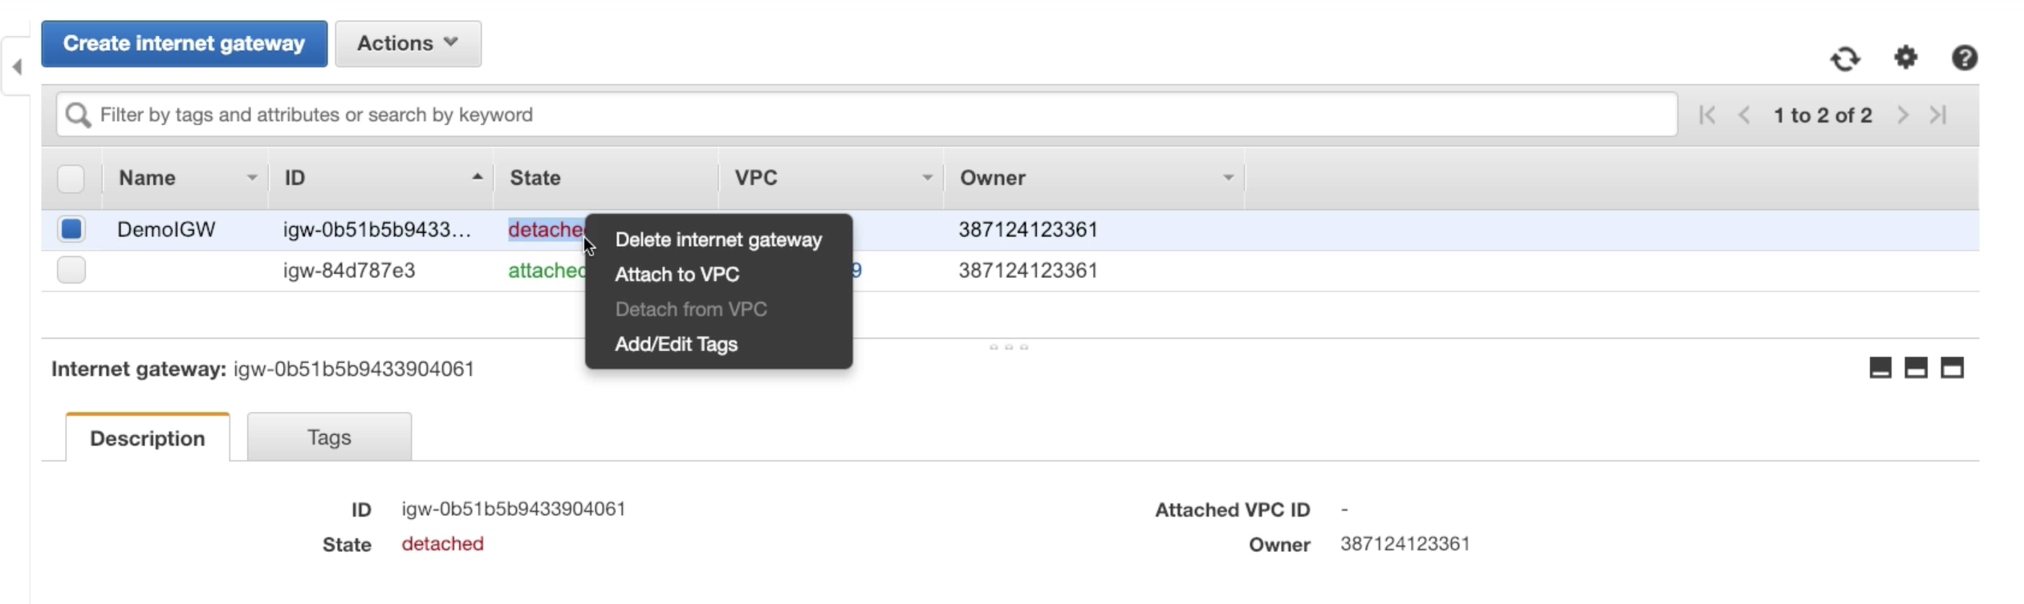

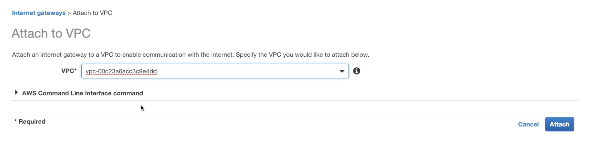

## Create Route Table

With Default VPC, a main route table comes by default. We can use the main route table or create our own.

* Public Route Table

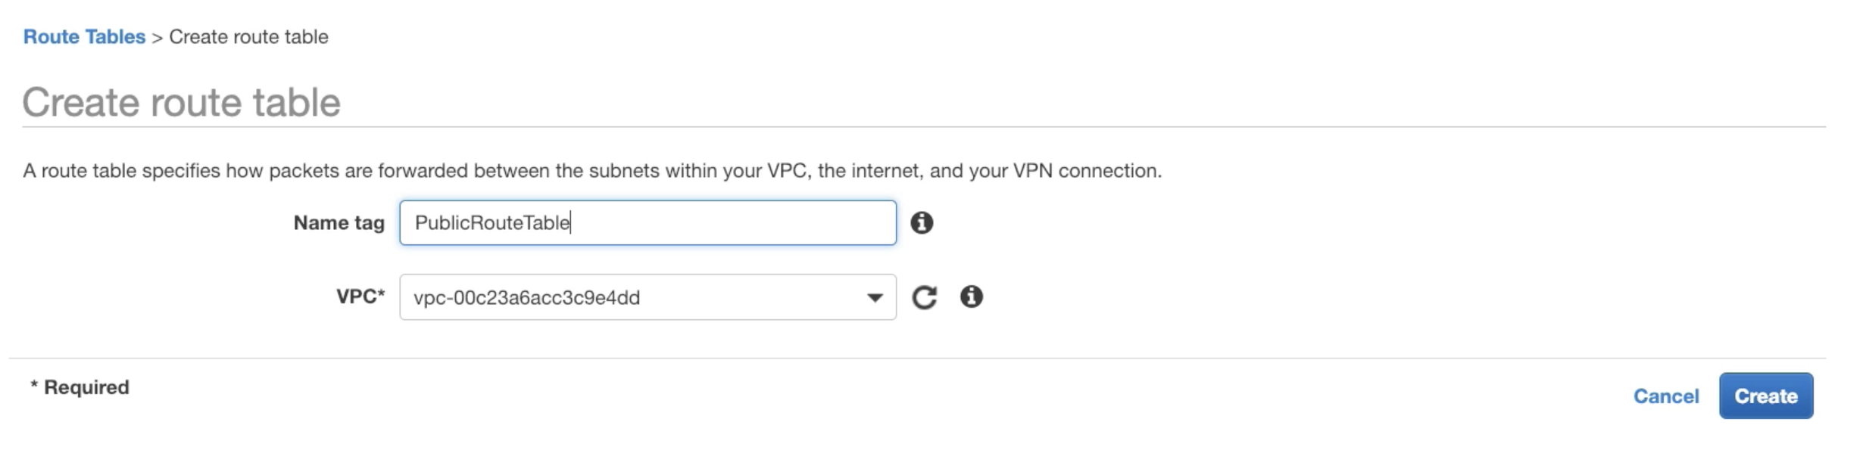

* Private Route Table

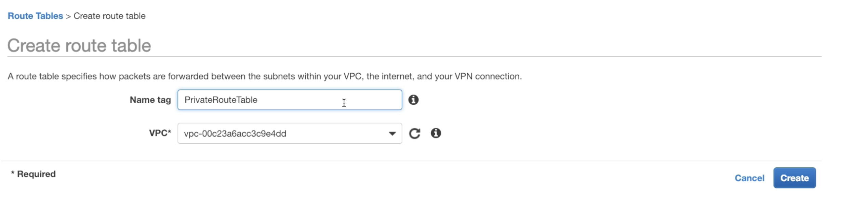

## Associate your Route table with Subnets

* Select the route table 🡪 go to Subnet Association tab 🡪 click on – Edit Subnet Associations
* Choose the subnet and save

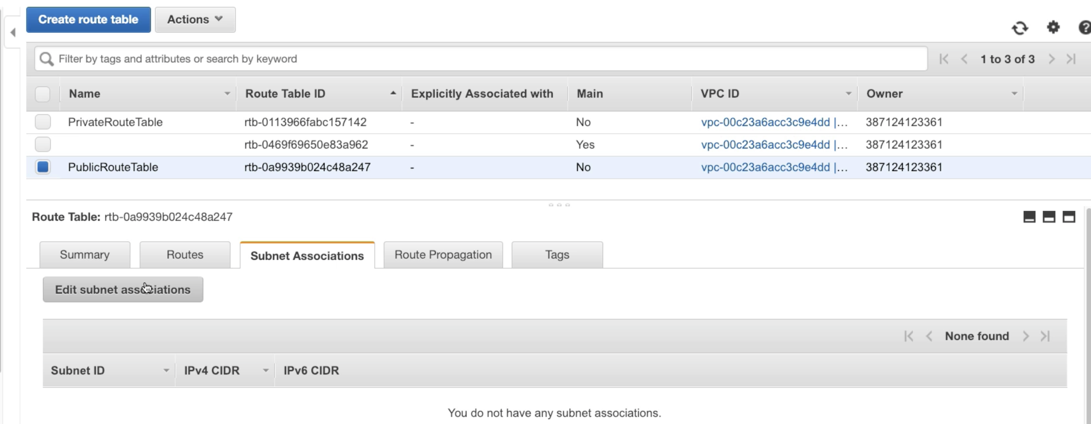

## Edit Routes of Route Table

* Select Public Route Table 🡪 select Routes tab 🡪 click on Edit Routes 🡪

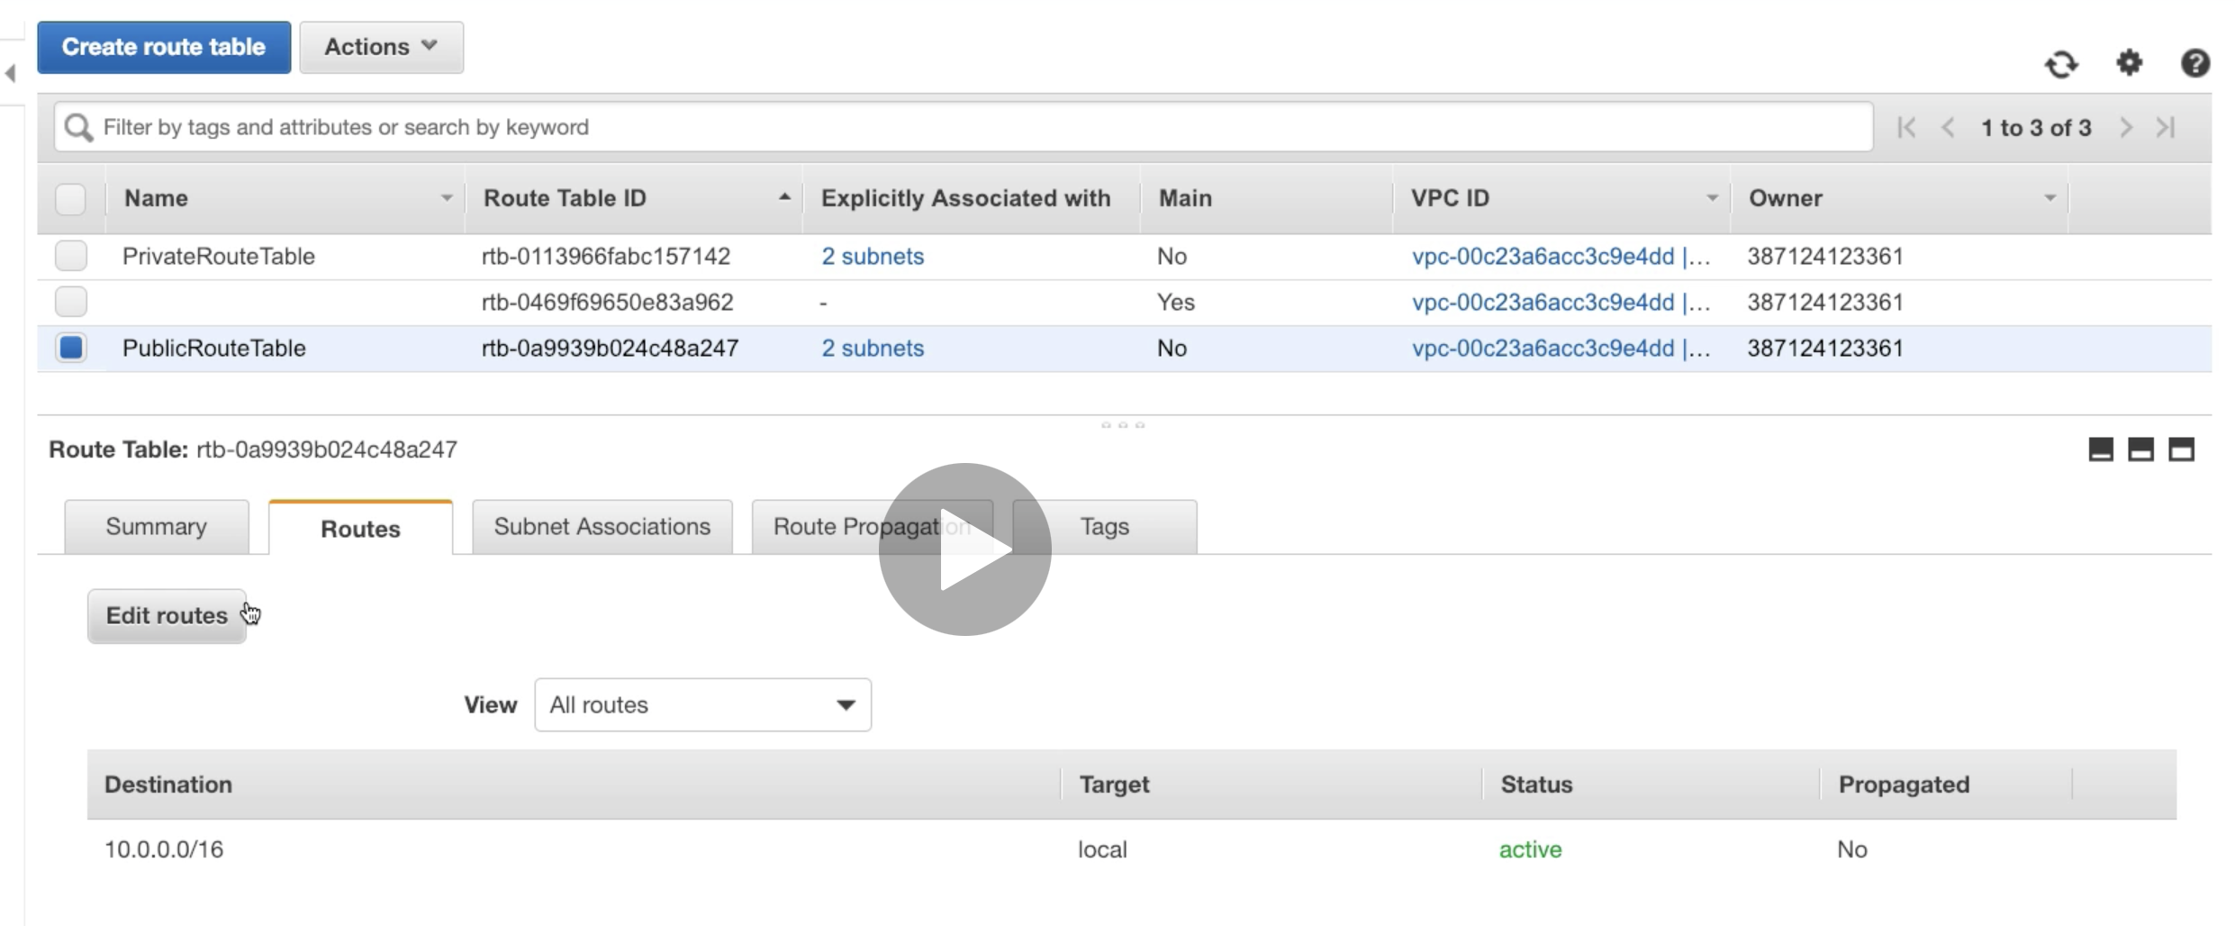

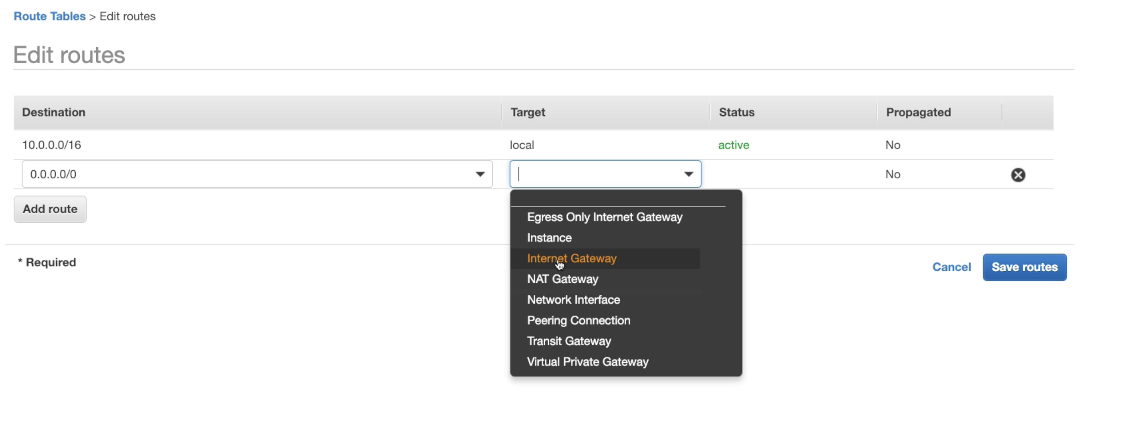

Note:

Once we associate our route table with subnets, and Routes of Route Table with IGW … now the EC2 instances created within that subnet will have access to internet.

Test:

* Try to SSH into the EC2 instance…
* If successful, run 🡪 sudo yum update

# 243. NAT Instances

Problem statement:

Instances within public subnet have internet connectivity through IGW. But instances within the private subnet cannot access internet. *If they were to use internet through IGW, they will also be directly accessible through internet*.

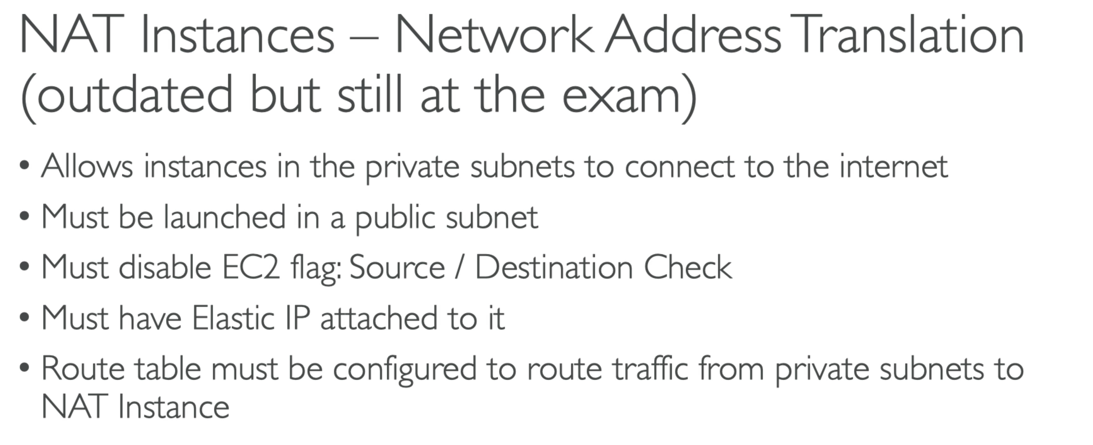

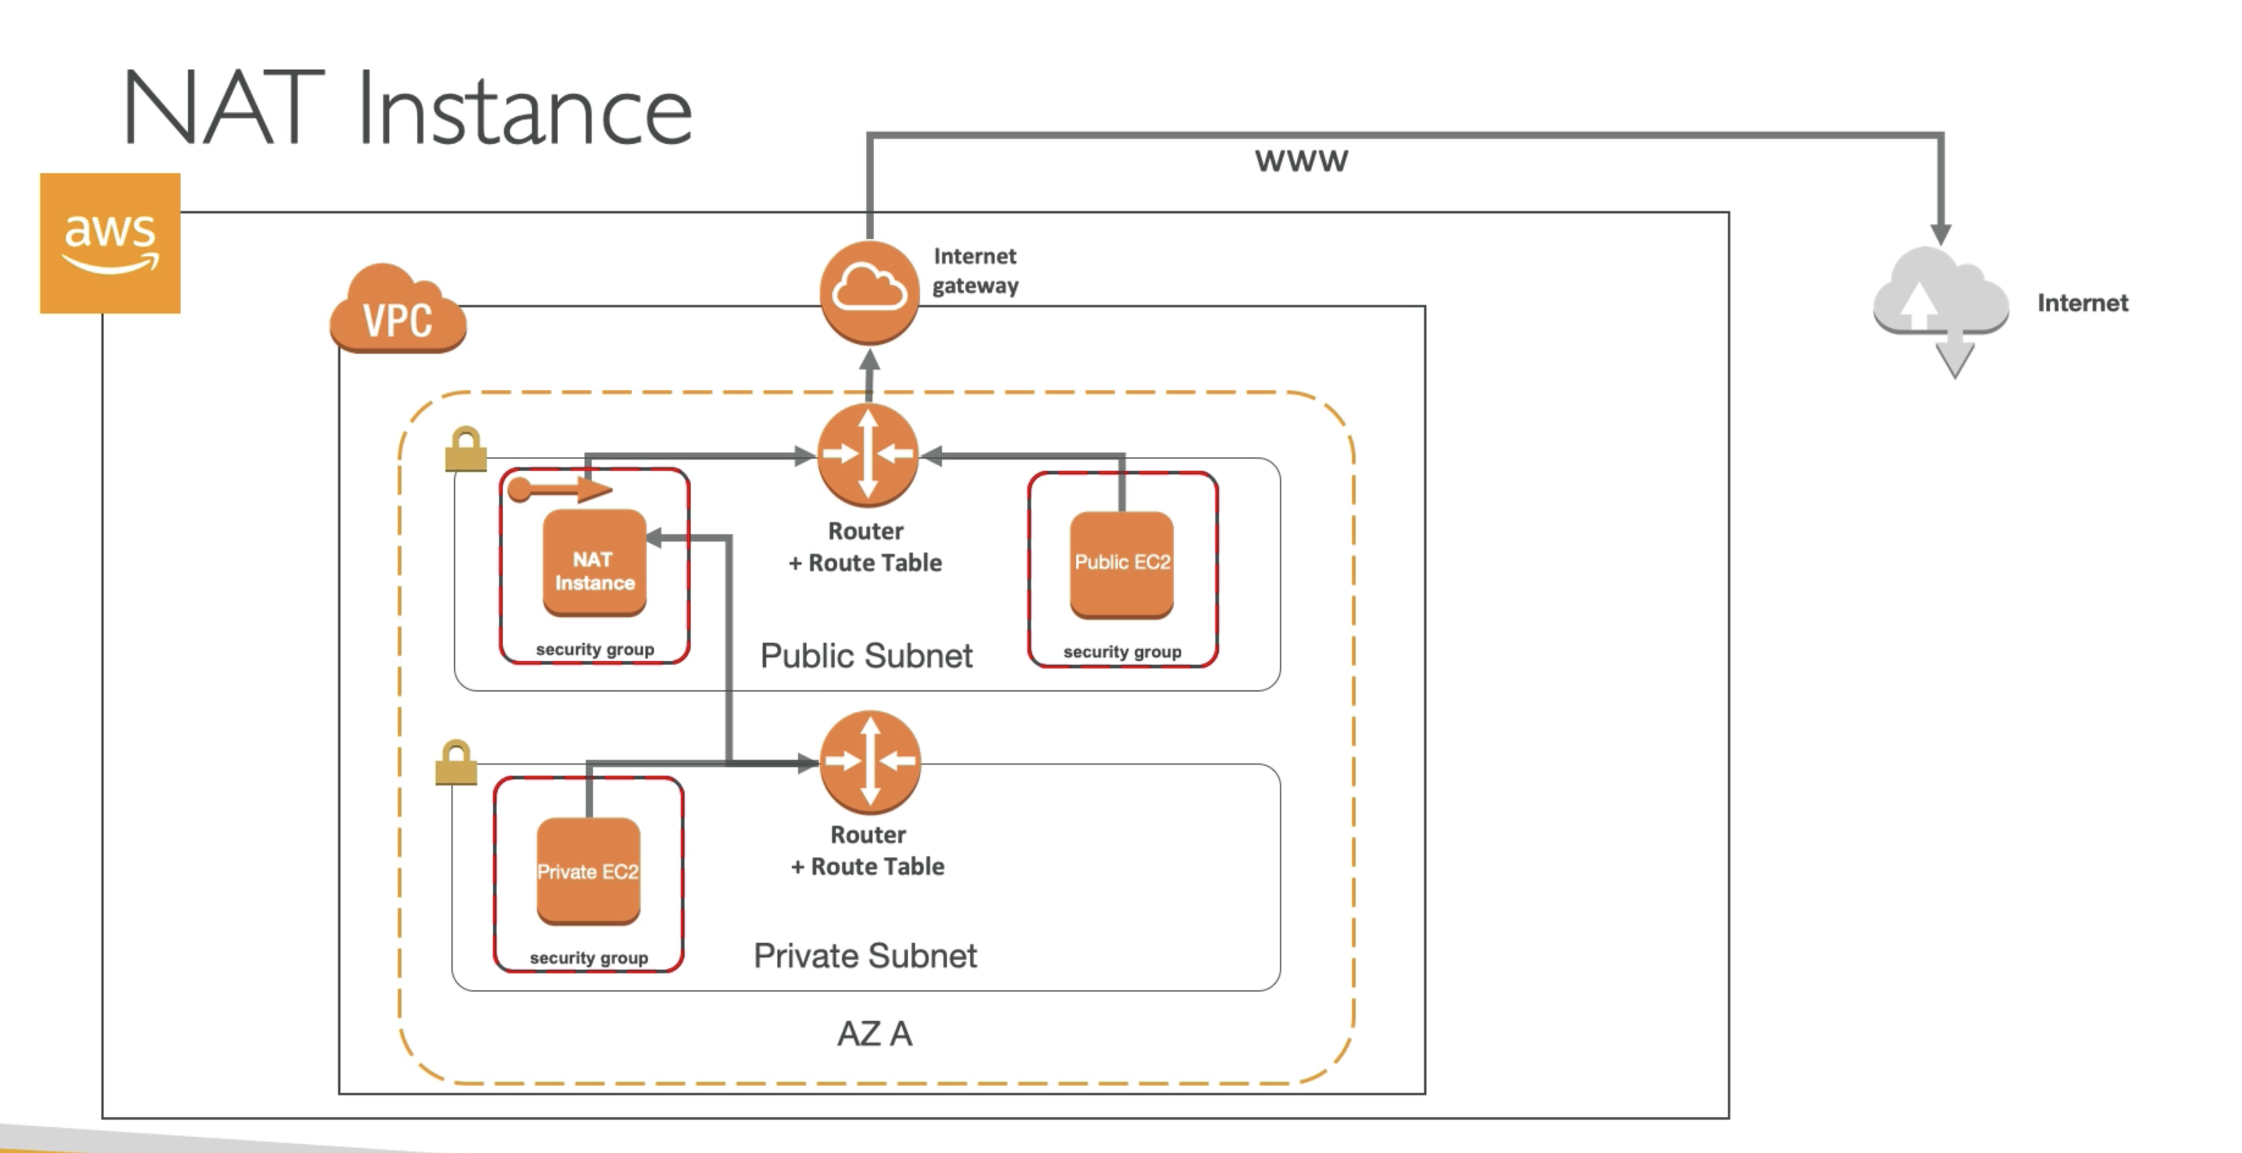

## Setup NAT Instance:

* We will create a NAT instance in the public subnet, with an elastic IP attached to it and it will have its own security group.
* This NAT instance will be able to access internet using the Router and the Route table.
* Now we need to bridge between oue private EC2 and the NAT instance. For this, we are going to change the route table in our private subnet, so that the route table points to the NAT instance in public subnet.
* This will allow EC2 instance to direct to NAT instance, which in turn is directed to internet.

## Necessary security group rule, when you launch a NAT instance:

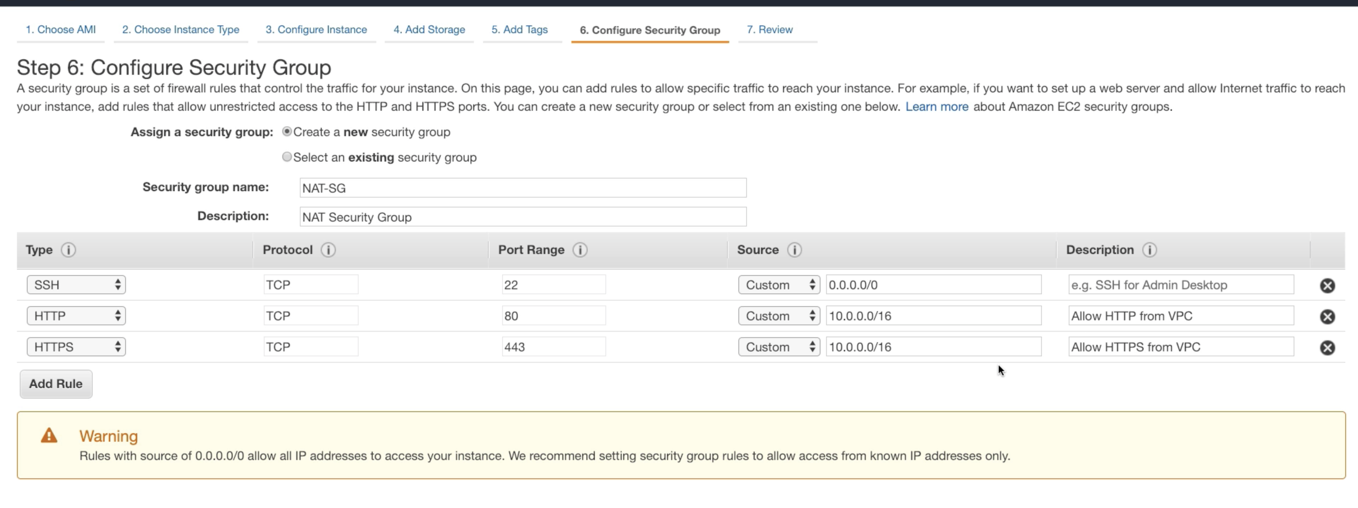

## Disable Source/Destination check for NAT instances:

* Right click on the instance 🡪 networking 🡪 Change Source/Dest Check
* We should keep it enabled for every instance except NAT

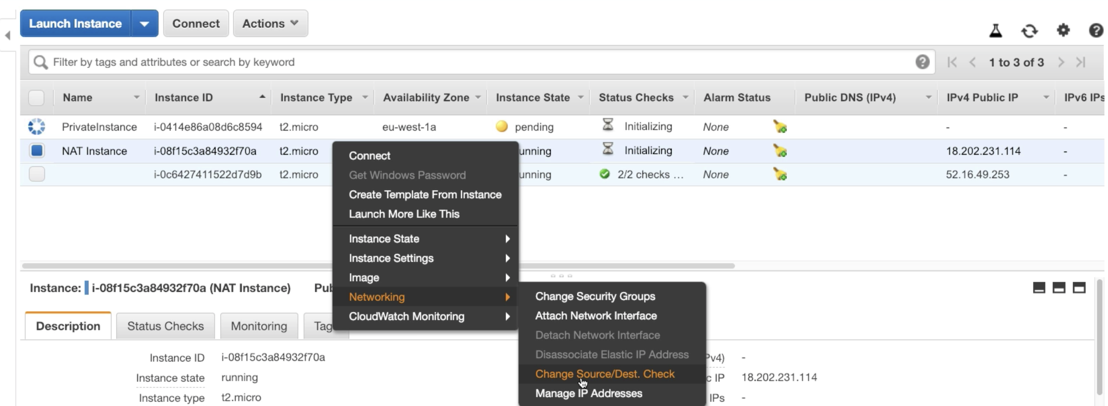

## Update Route table of the private subnet to point traffic to NAT instance

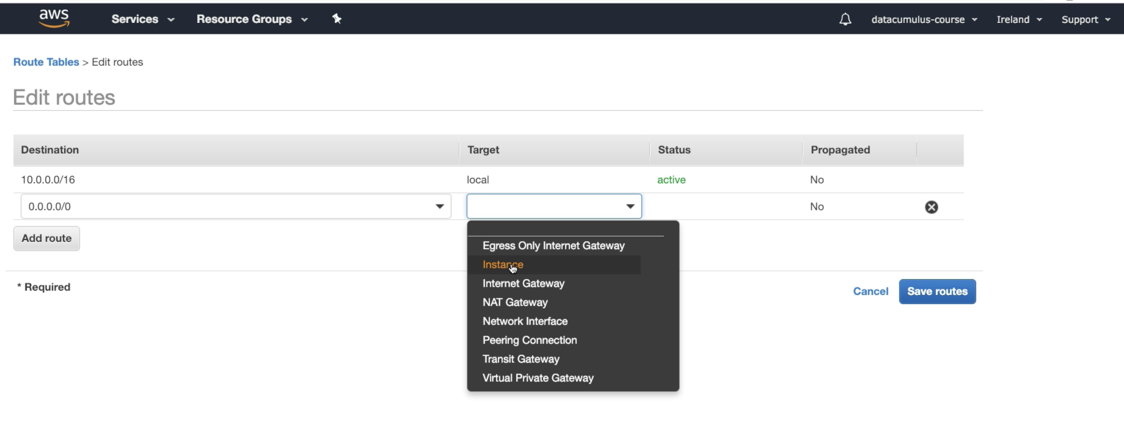

## Update Security Group for the NAT instance to allow traffic:

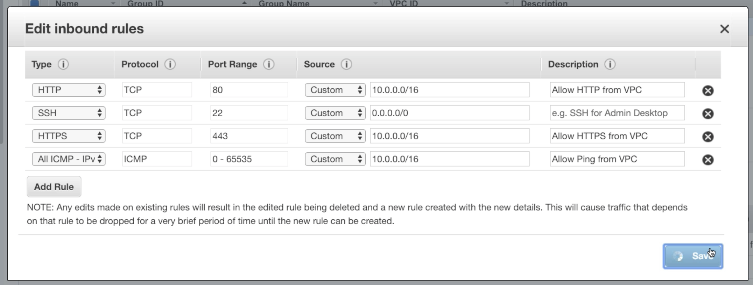

If you delete your NAT instance, in the PrivateRouteTable … Route that was pointing to NAT instance will not show the status as blackhole. This also indicates the private EC2 instance has lost internet connection.

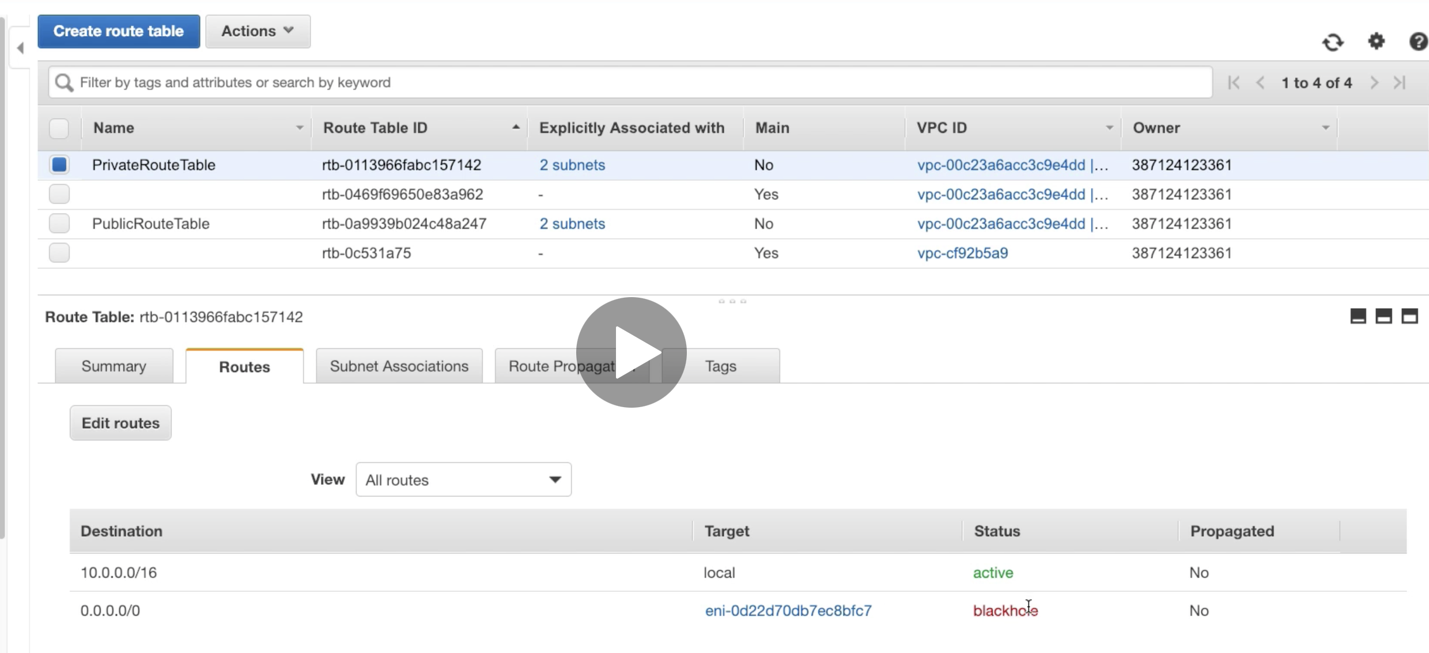

## Summary of NAT instance

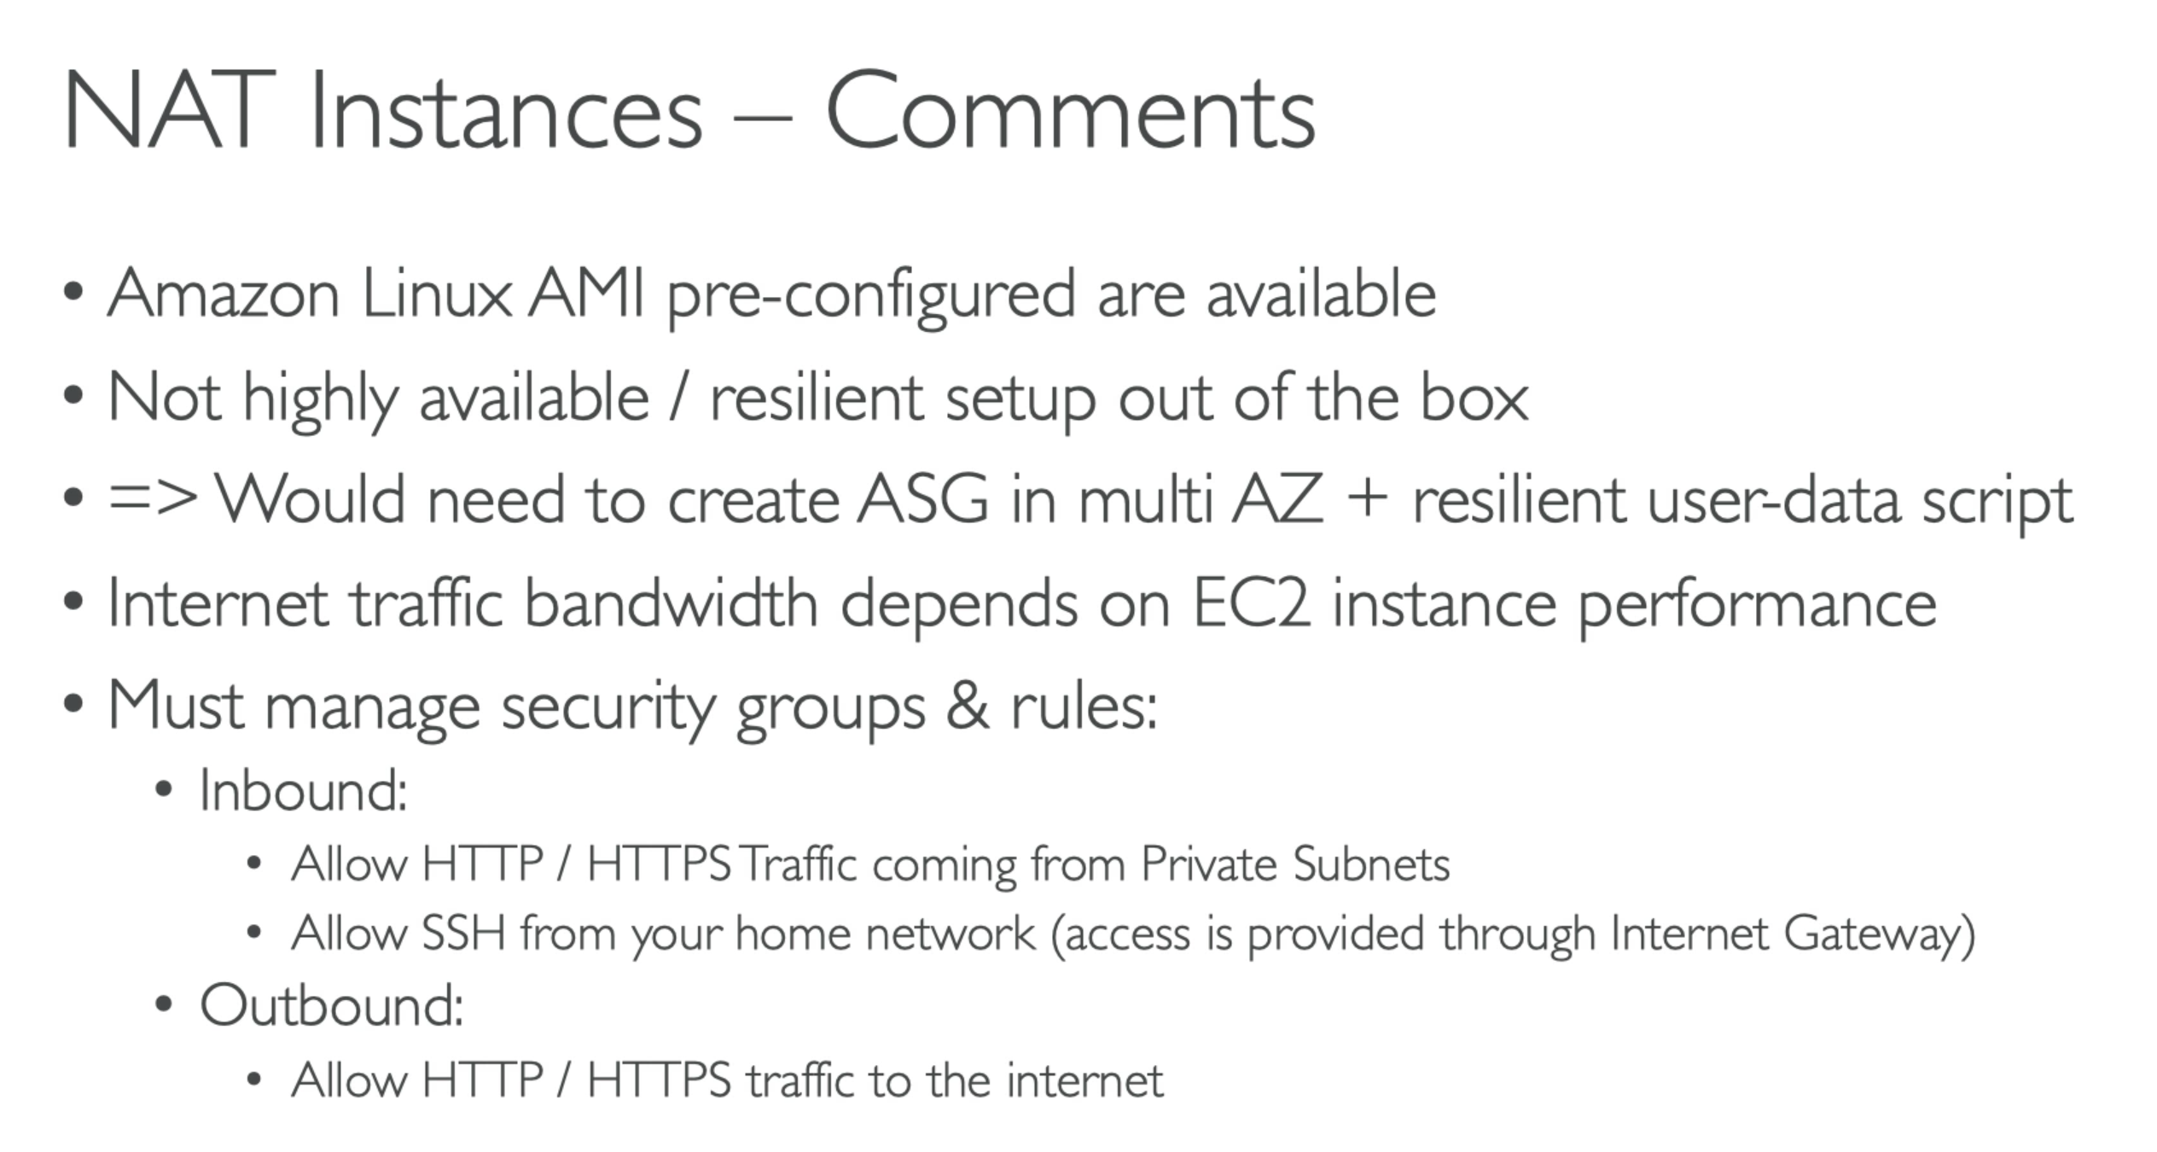

# 244. NAT Gateway

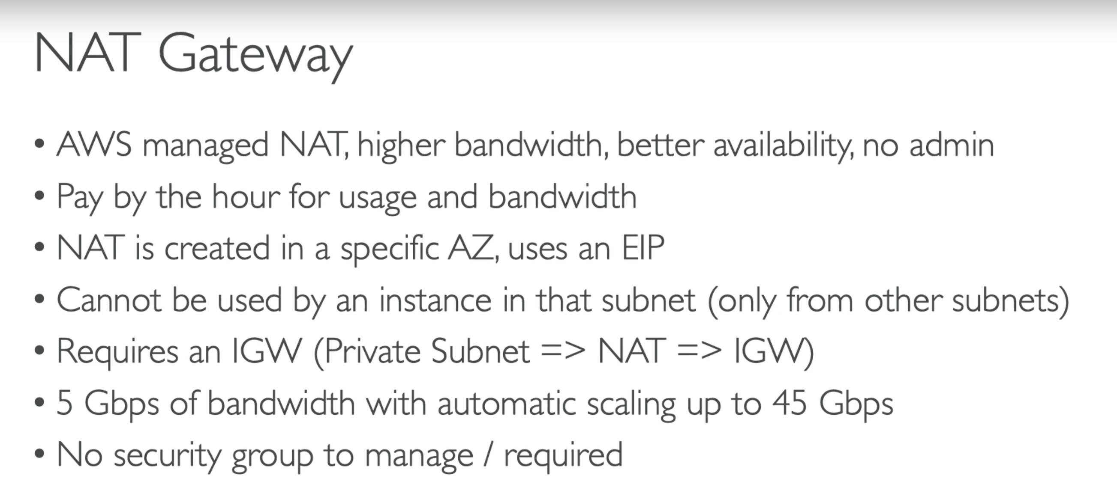

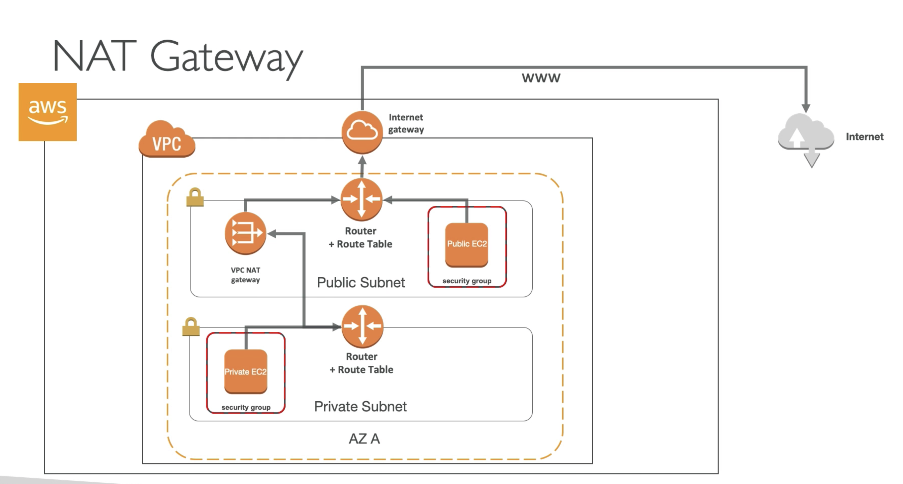

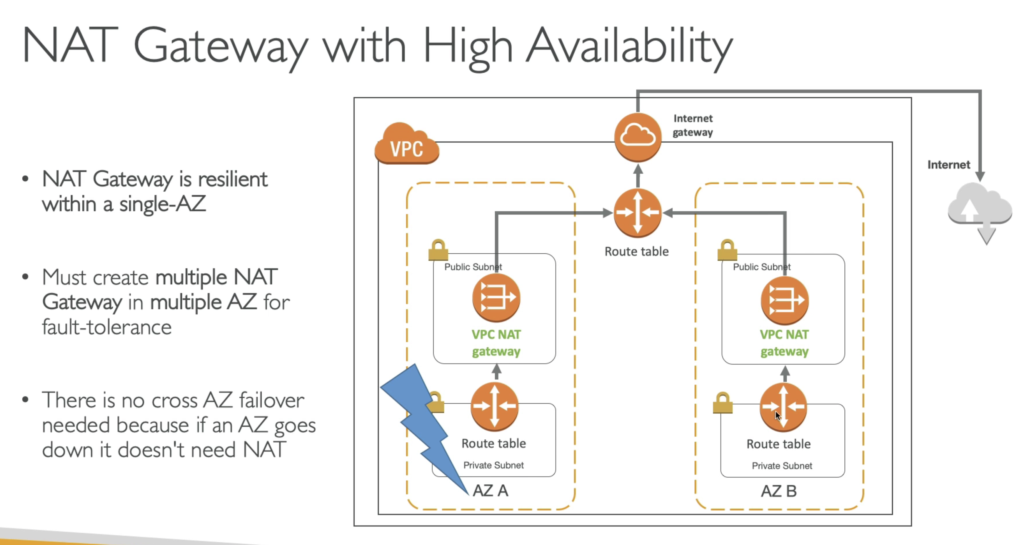

NOTE: For High availability, you should setup NAT Gateway one in each AZ.

## Create NAT Gateway

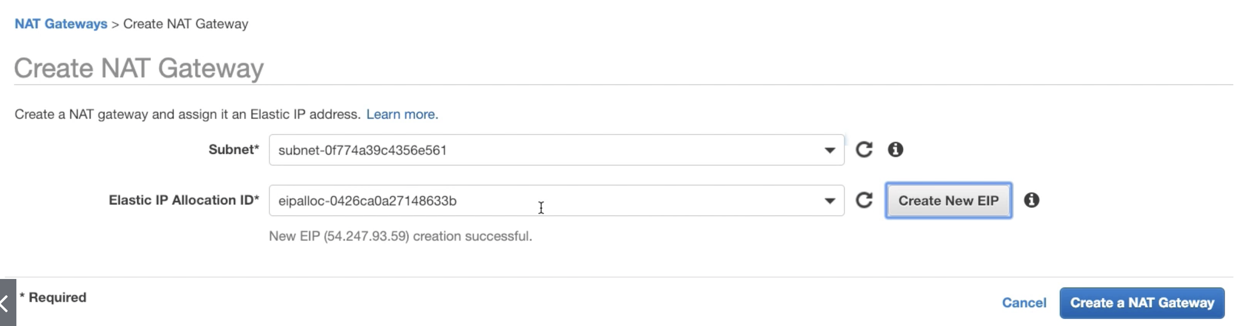

## Update Private Route Table, to point to NAT Gateway

* Open PrivateRouteTable 🡪 Routes tab 🡪 Edit Route 🡪
* Update the NAT Gateway against destination 0.0.0.0/0

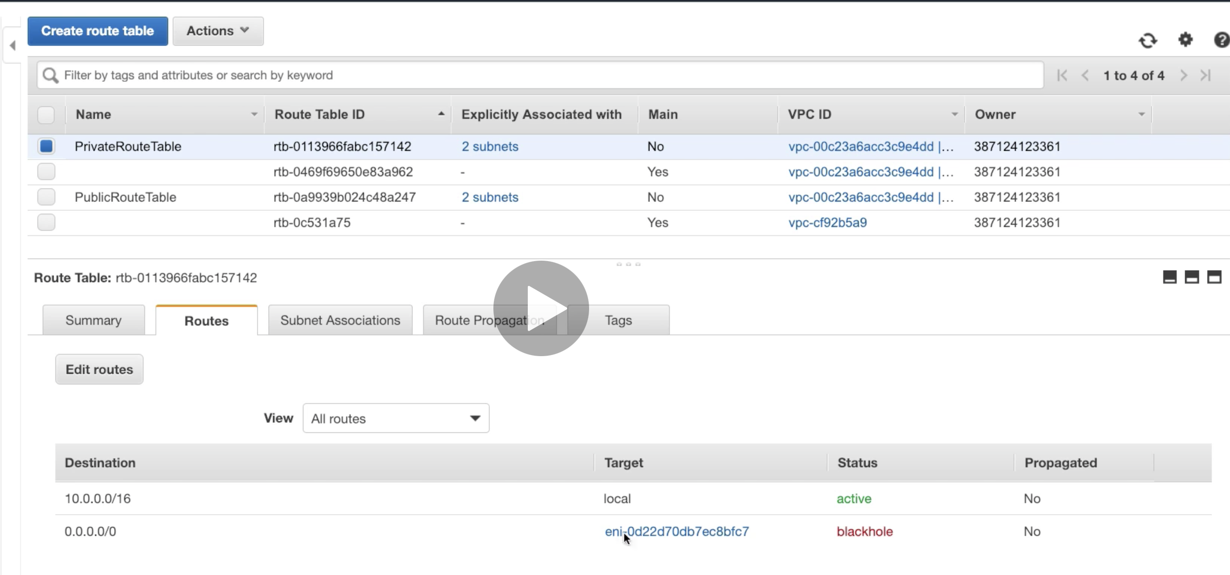

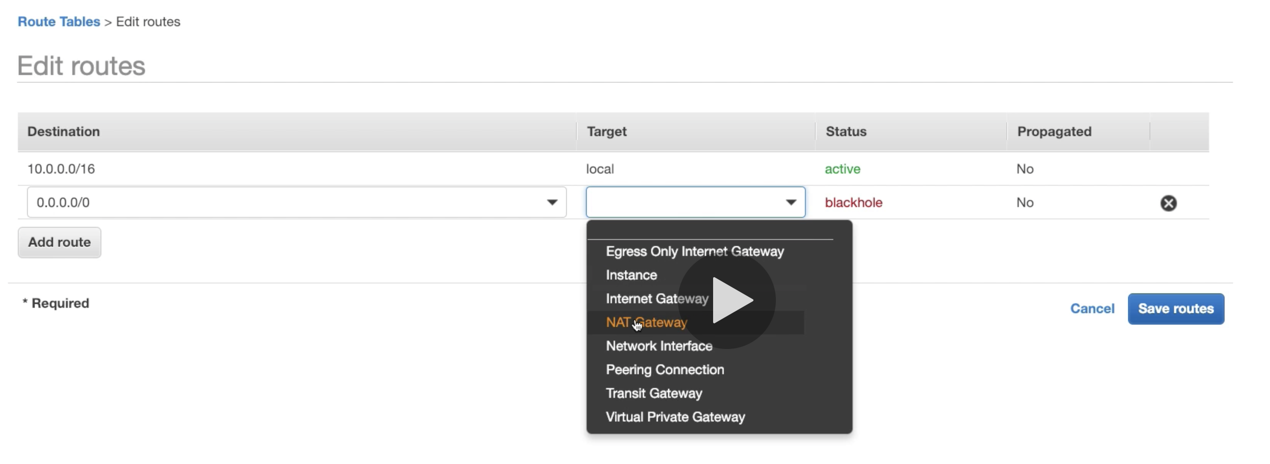

## NAT Gateway Vs NAT instance

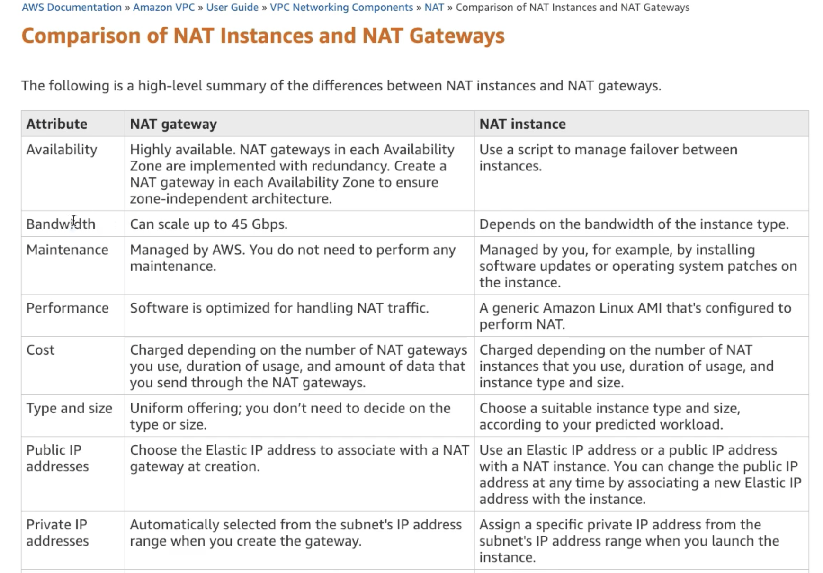

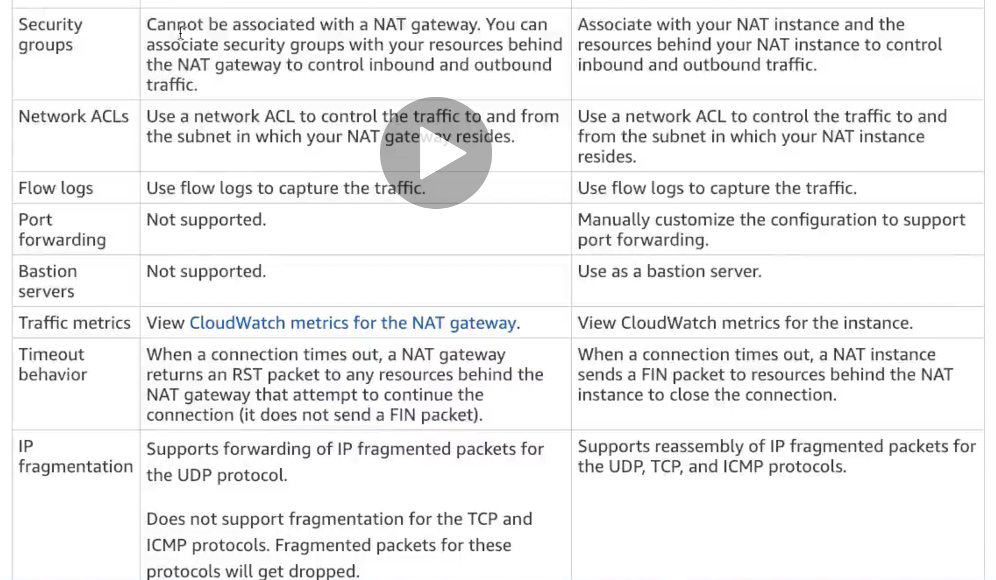

# 245. DNS Resolutions & Route 53 Private Zones

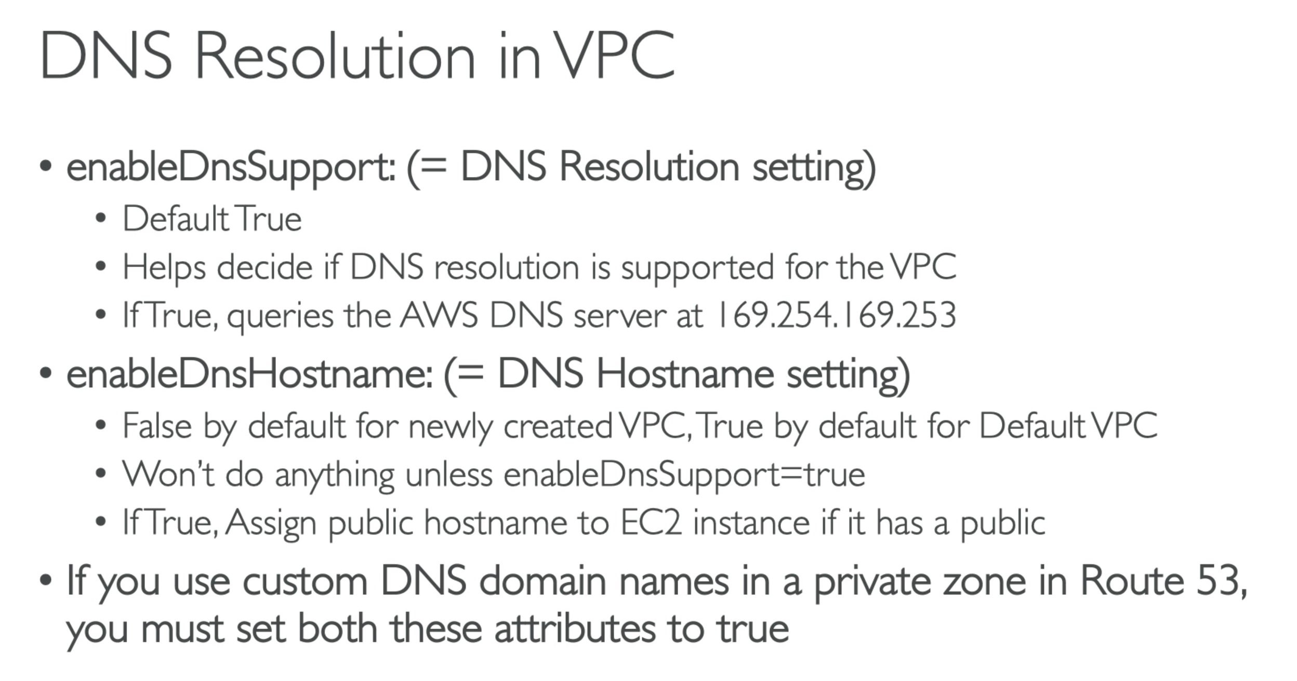

# 246. NACL & Security Groups

## Incoming Request

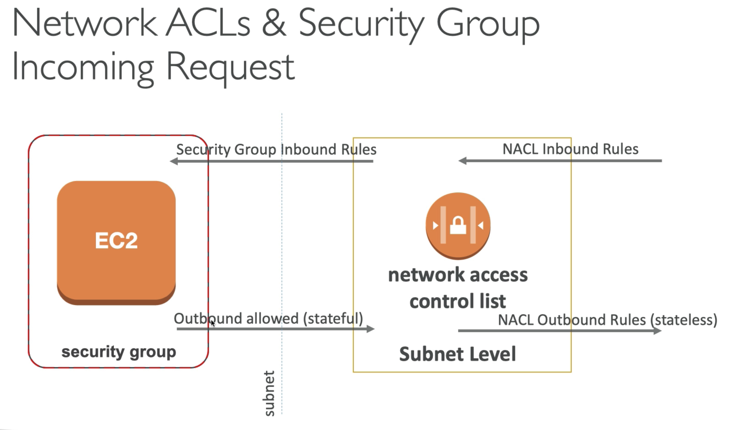

* Architecture
  + We have an EC2 instance and a security group around it. EC2 is a webserver and we expose an apache on port 22
  + EC2 resides in a subnet
  + Outside subnet there is a NACL
* Inbound request flow:
  + Incoming traffic first evaluated against NACL inbound rules
  + If inbound rules passes, it is passed on to the security group inbound rules
  + If SG inbound rules passes, then Webserver on EC2 instance will receive the request
* Outbound flow
  + SG is **stateful**, so if the inbound request passes … outbound will also be allowed, 🡪 even if there is an outbound rule to deny traffic out of the EC2 instance
  + NACL outbound rules are **stateless**, so the response will now be evaluated against it.

Note:

NACL is stateless 🡪 so both inbound and outbound rules will get evaluated

SG is stateful 🡪 if inbound rule passes, outbound will automatically pass

## Outbound Request

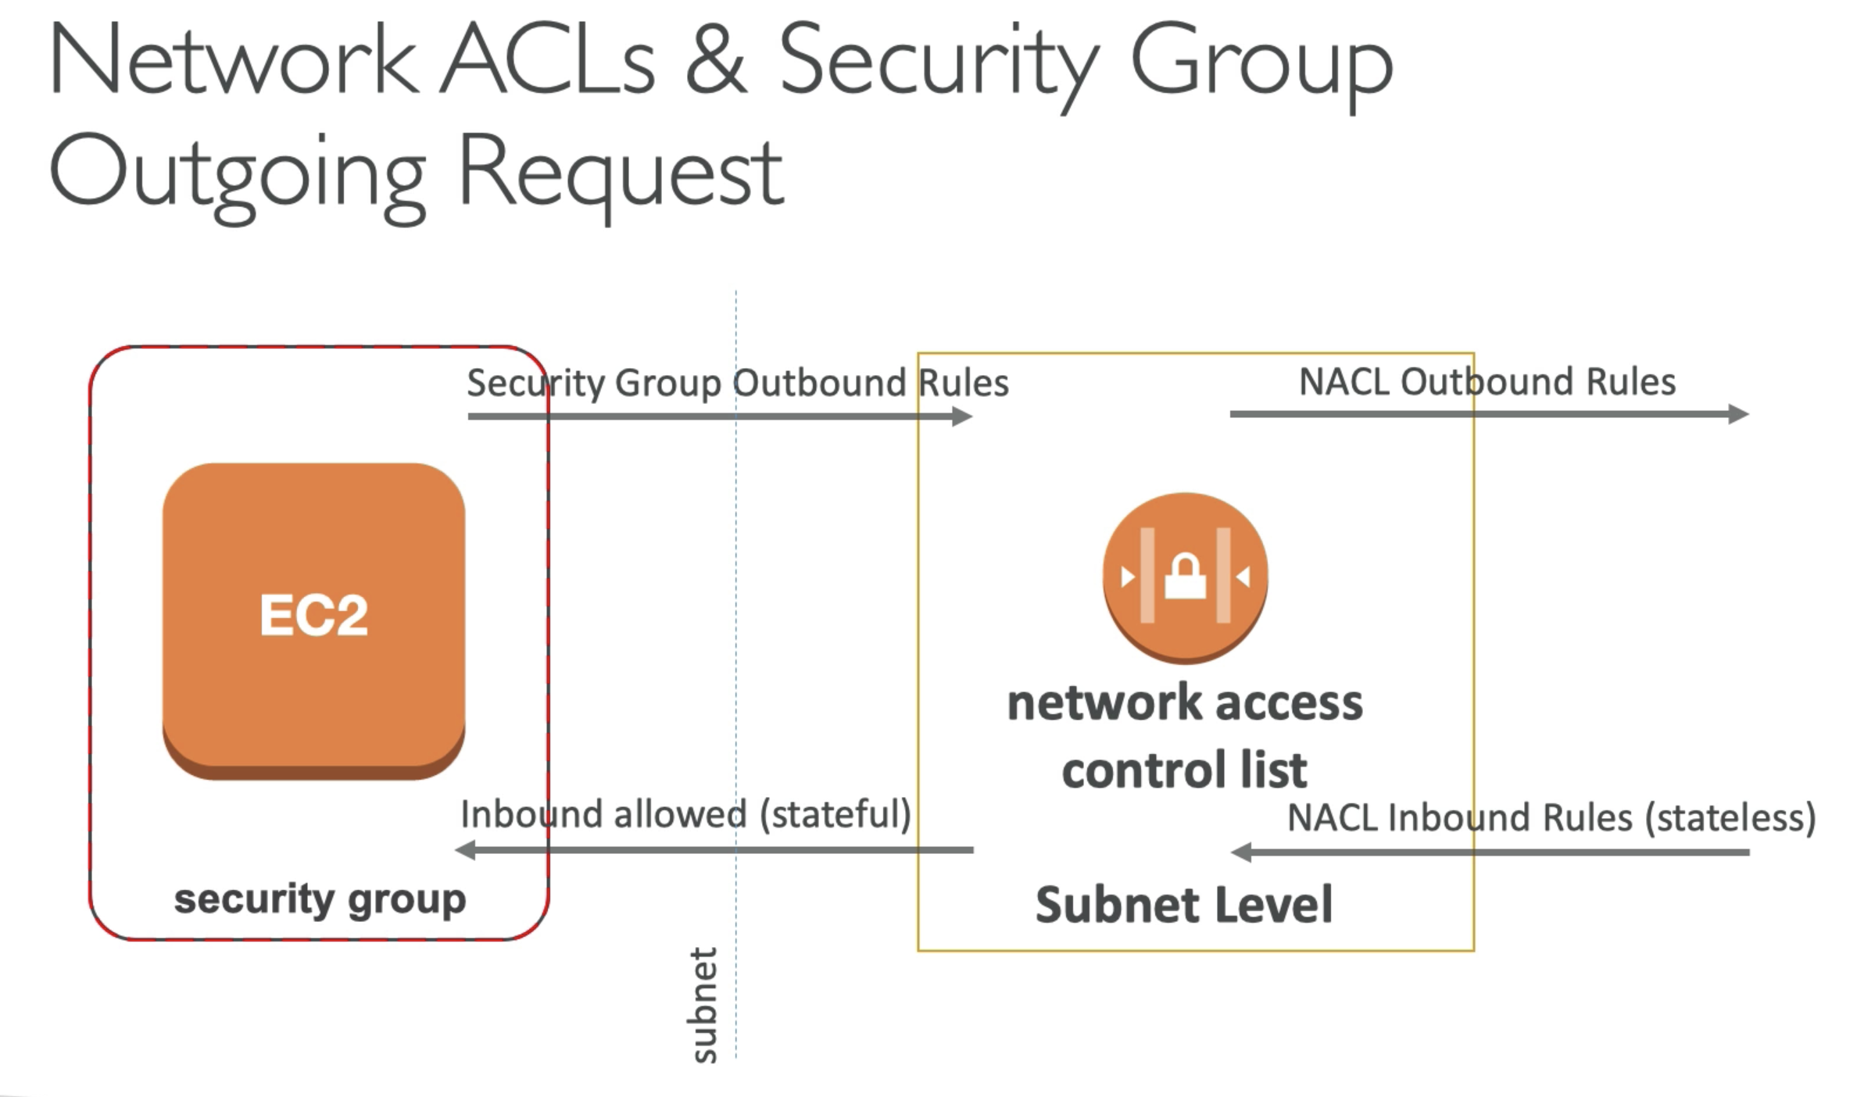

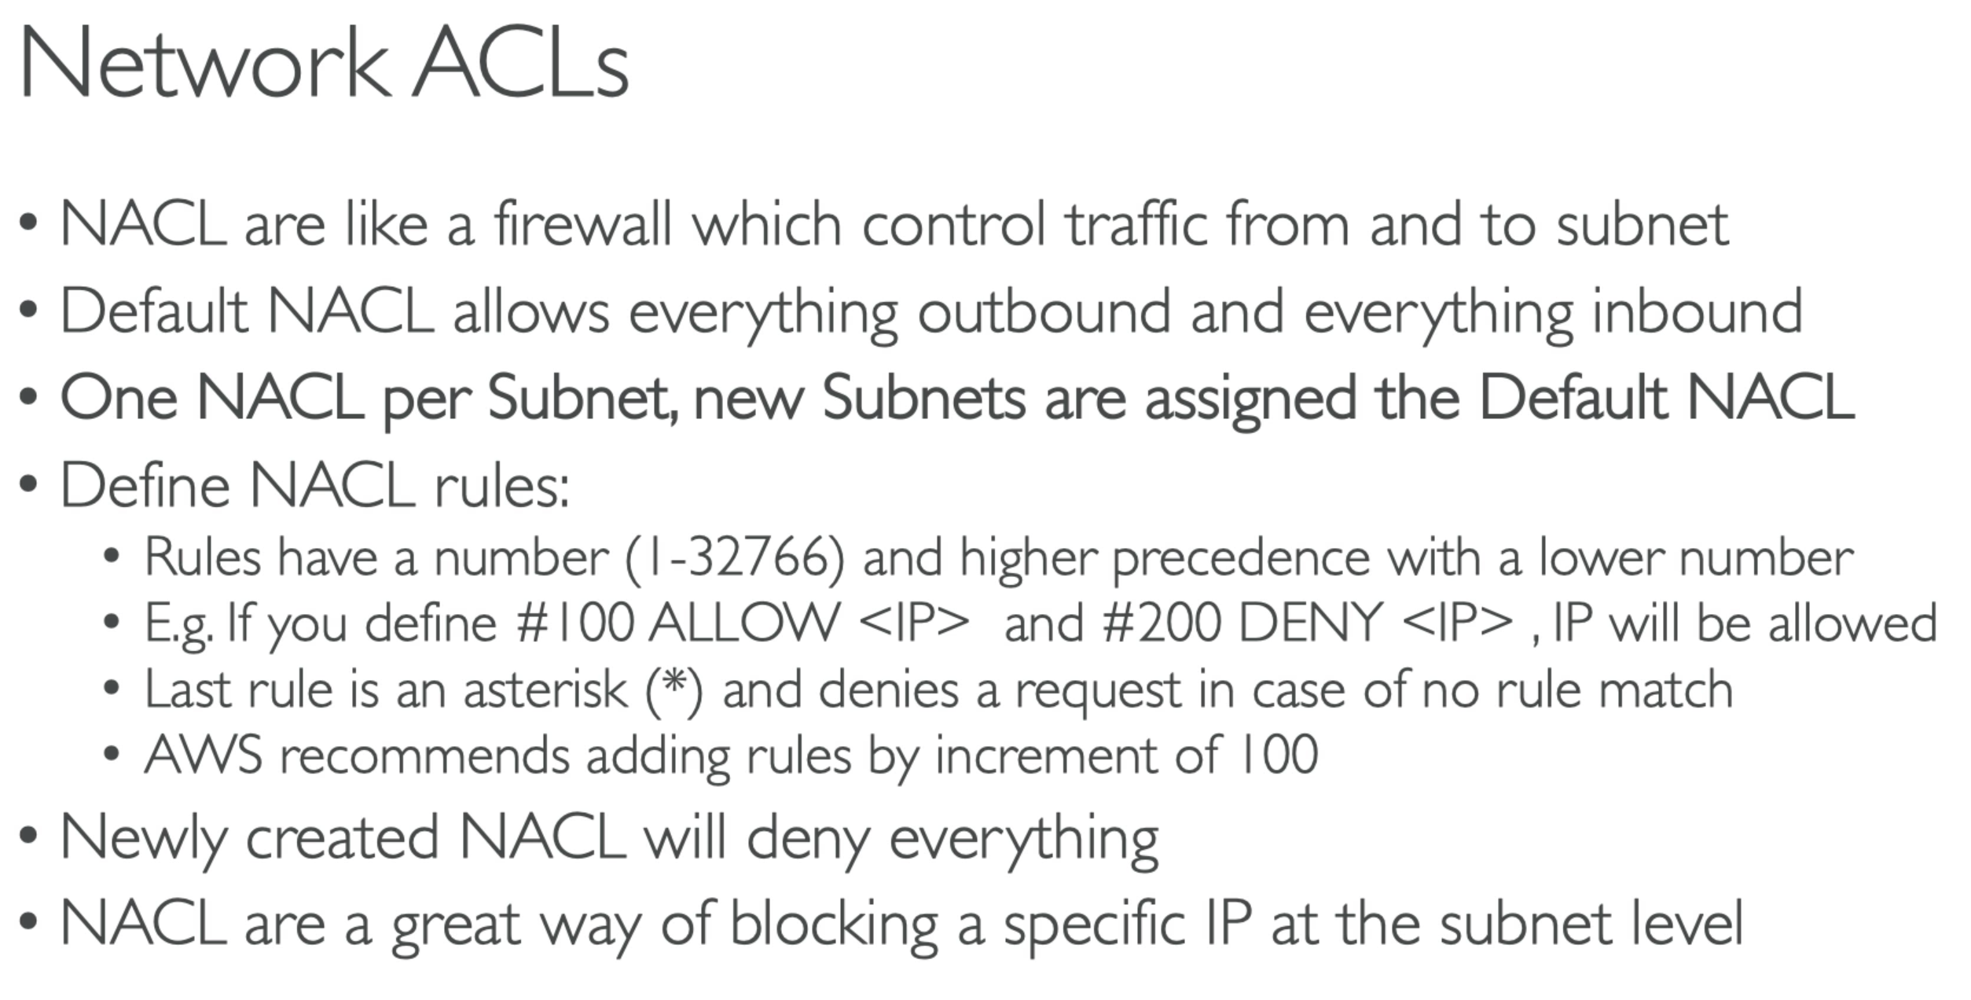

## Default NACL – Inbound rule

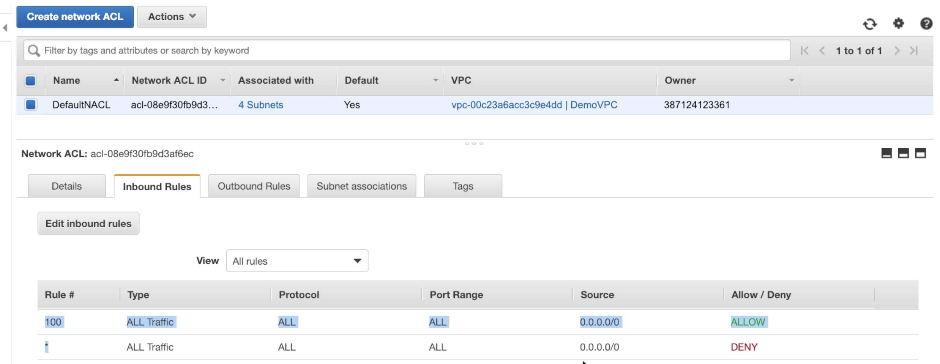

## SG Vs NACL

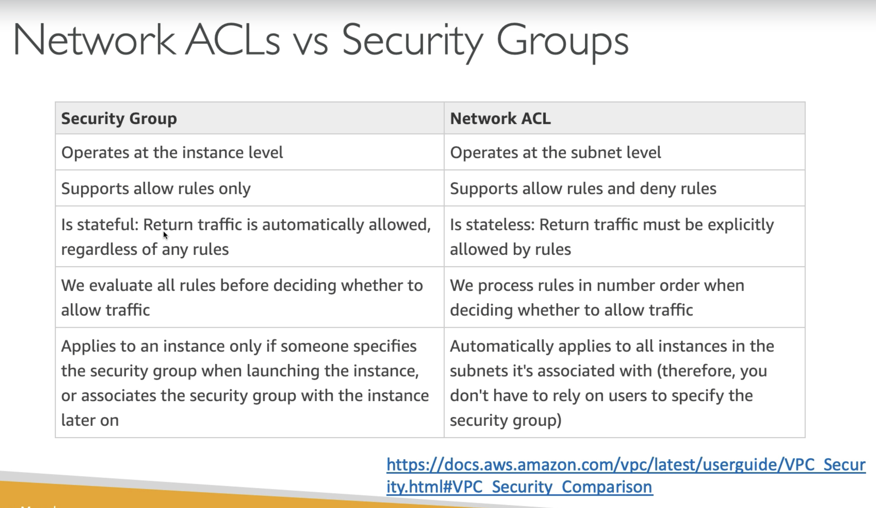

# 247. VPC Peering

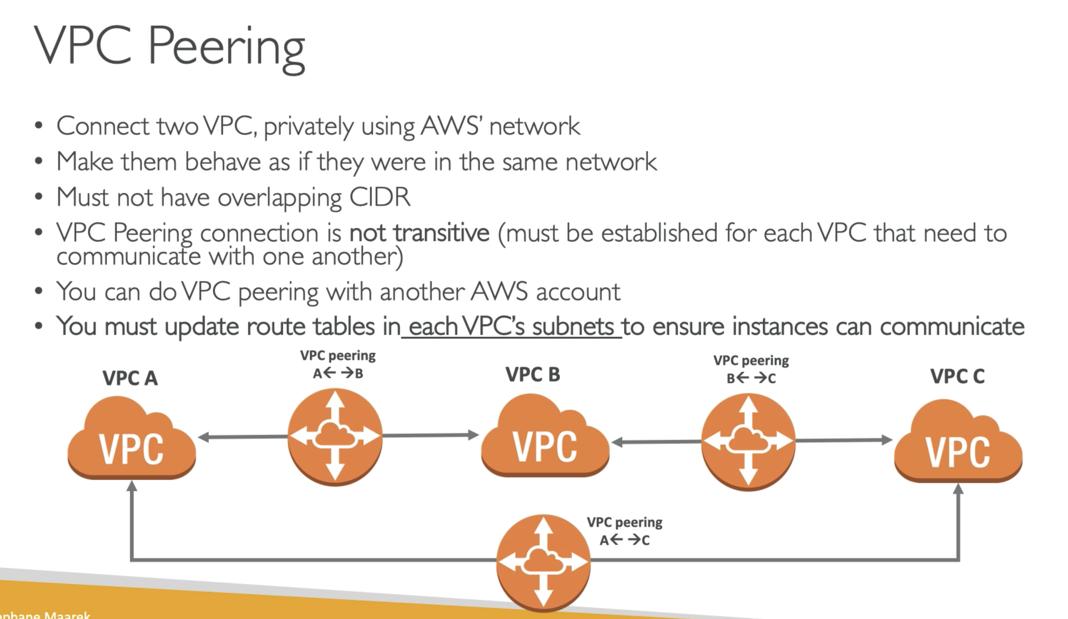

ExamTip:

Trick question may come from last two points: transitiveness and updating route table

# 248. VPC Endpoint

Problem statement –

How do we access AWS resources like S3, DynamoDB or cloud watch from a private EC2 instance?

* Once of the approach is that – EC2 instance will talk to NAT Gateway and then to IGW and then get to internet … and then access AWS resources …. This is not the right approach … because to access the resources within AWS, we need to traverse through internet.   
  We should keep all these traffic private.
* Alternative approach is the VPC endpoint   
  VPC endpoint is meant for you to access AWS services over a private network.

Our instances on private subnet will be able to access VPC endpoint through some route table… and through VPC endpoint it will be able to talk to Amazon S3 etc privately

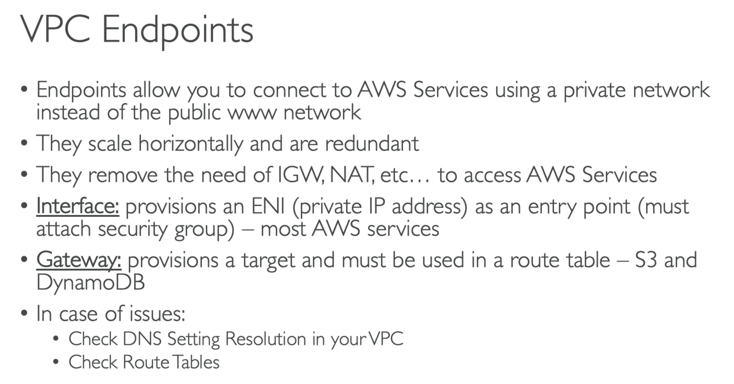

## Setup S3 as a Gateway

* Create a IAM role for EC2 that has AmazonS3FullAccess
* Go to your EC2 instance on private subnet, and attach the role
* Go to endpoint 🡪 Create endpoint
* Update route table
* SSH into the instance
* Run command 🡪 AWS S3 ls –region eu-west-1
  + **Very important to remember: default resion for AWS CLI is us-east-1. Our VPN endpoint was provisioned for eu-west-1. So while running the command we have to mention the –region. Otherwise the command wouldn’t work.**

# 249. VPC Flow Logs + Athena

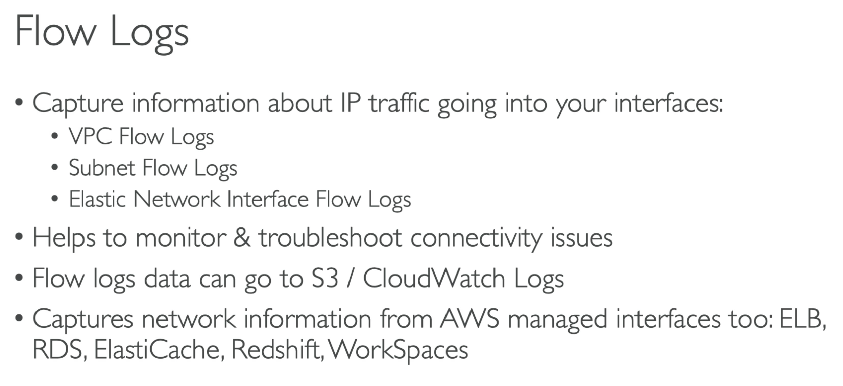

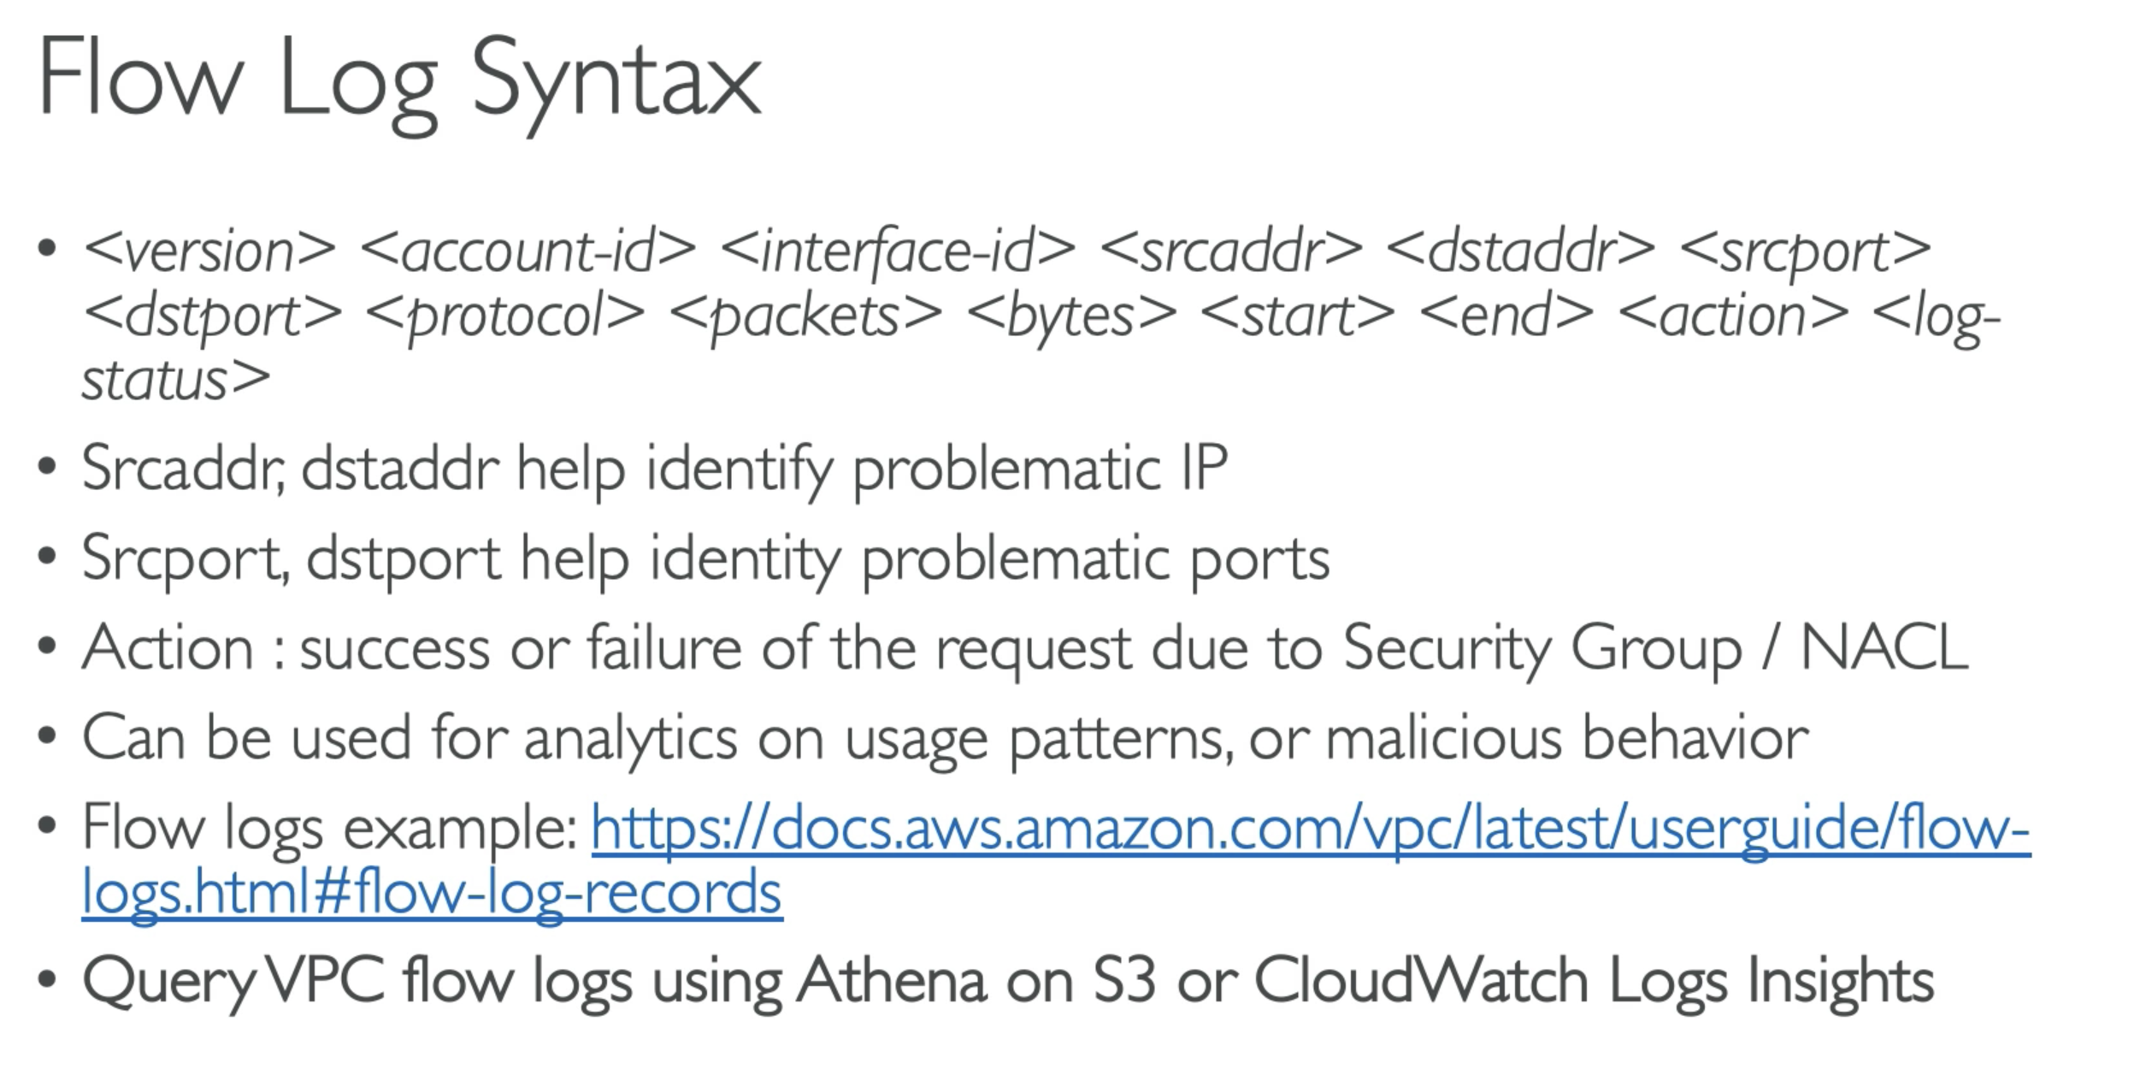

## Create flow logs on CloudWatch

* Go to CloudWatch 🡪 create a log group
* Go to your VPC 🡪 Flow Log tab 🡪 Create Flow Log
* Log destination 🡪 CloudWatch

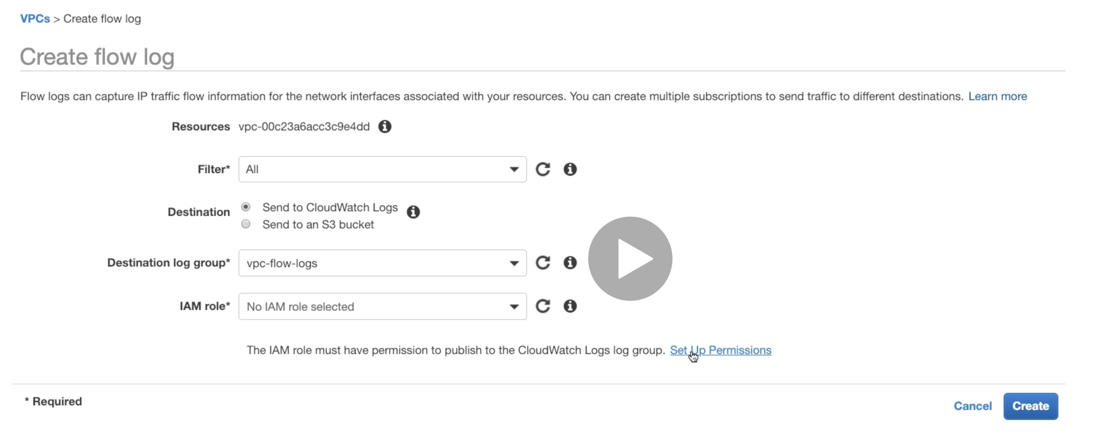

Note: ‘Set Up Permission’ link on screen will help create the IAM role.

## Create flow logs on S3

* 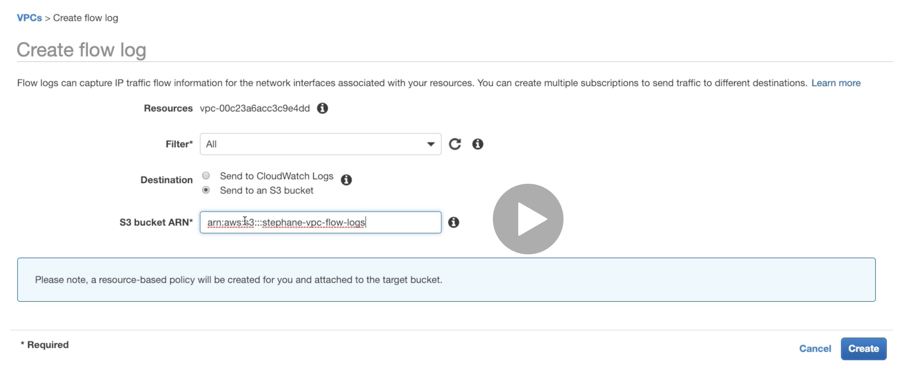

Note: go to S3 bucket 🡪 Copy bucket ARN

### ExamTip:

Q: How do you analyse VPC Flow Logs?

Ans: Athena

# 250. Bastion Host

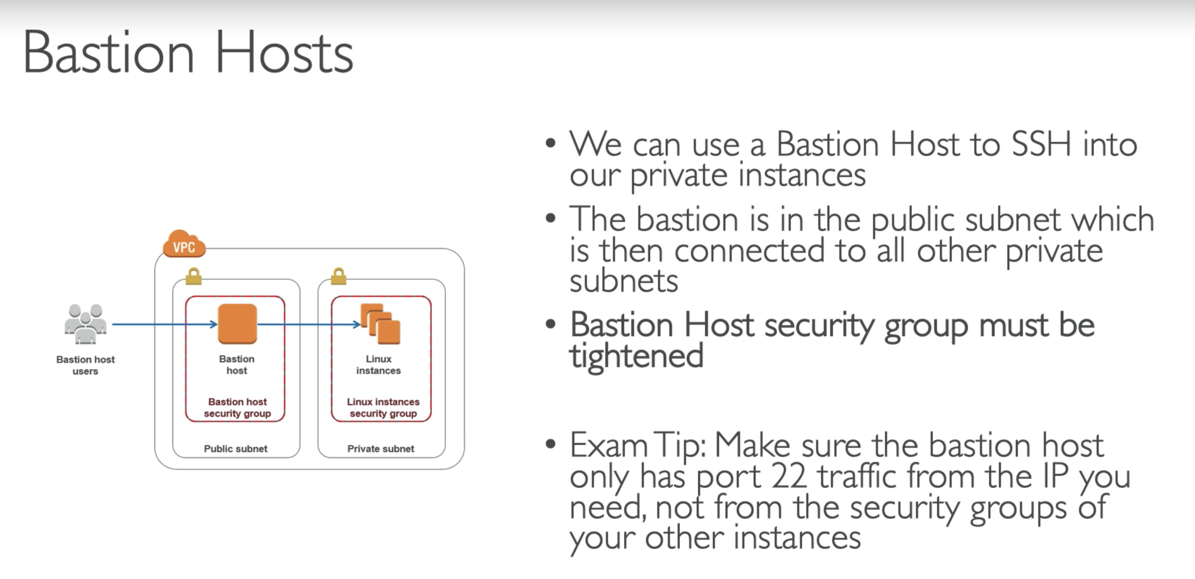

### ExamTip

When we have a public instance, that is also a Bastion host. Because in it’s security group, we did allow SSH into it. And it sits in the public instance.

# 251. Site to Site VPN, Virtual Private Gateway and Customer G

Connect your Corporate Data centres to AWS cloud somewhat directly or not.

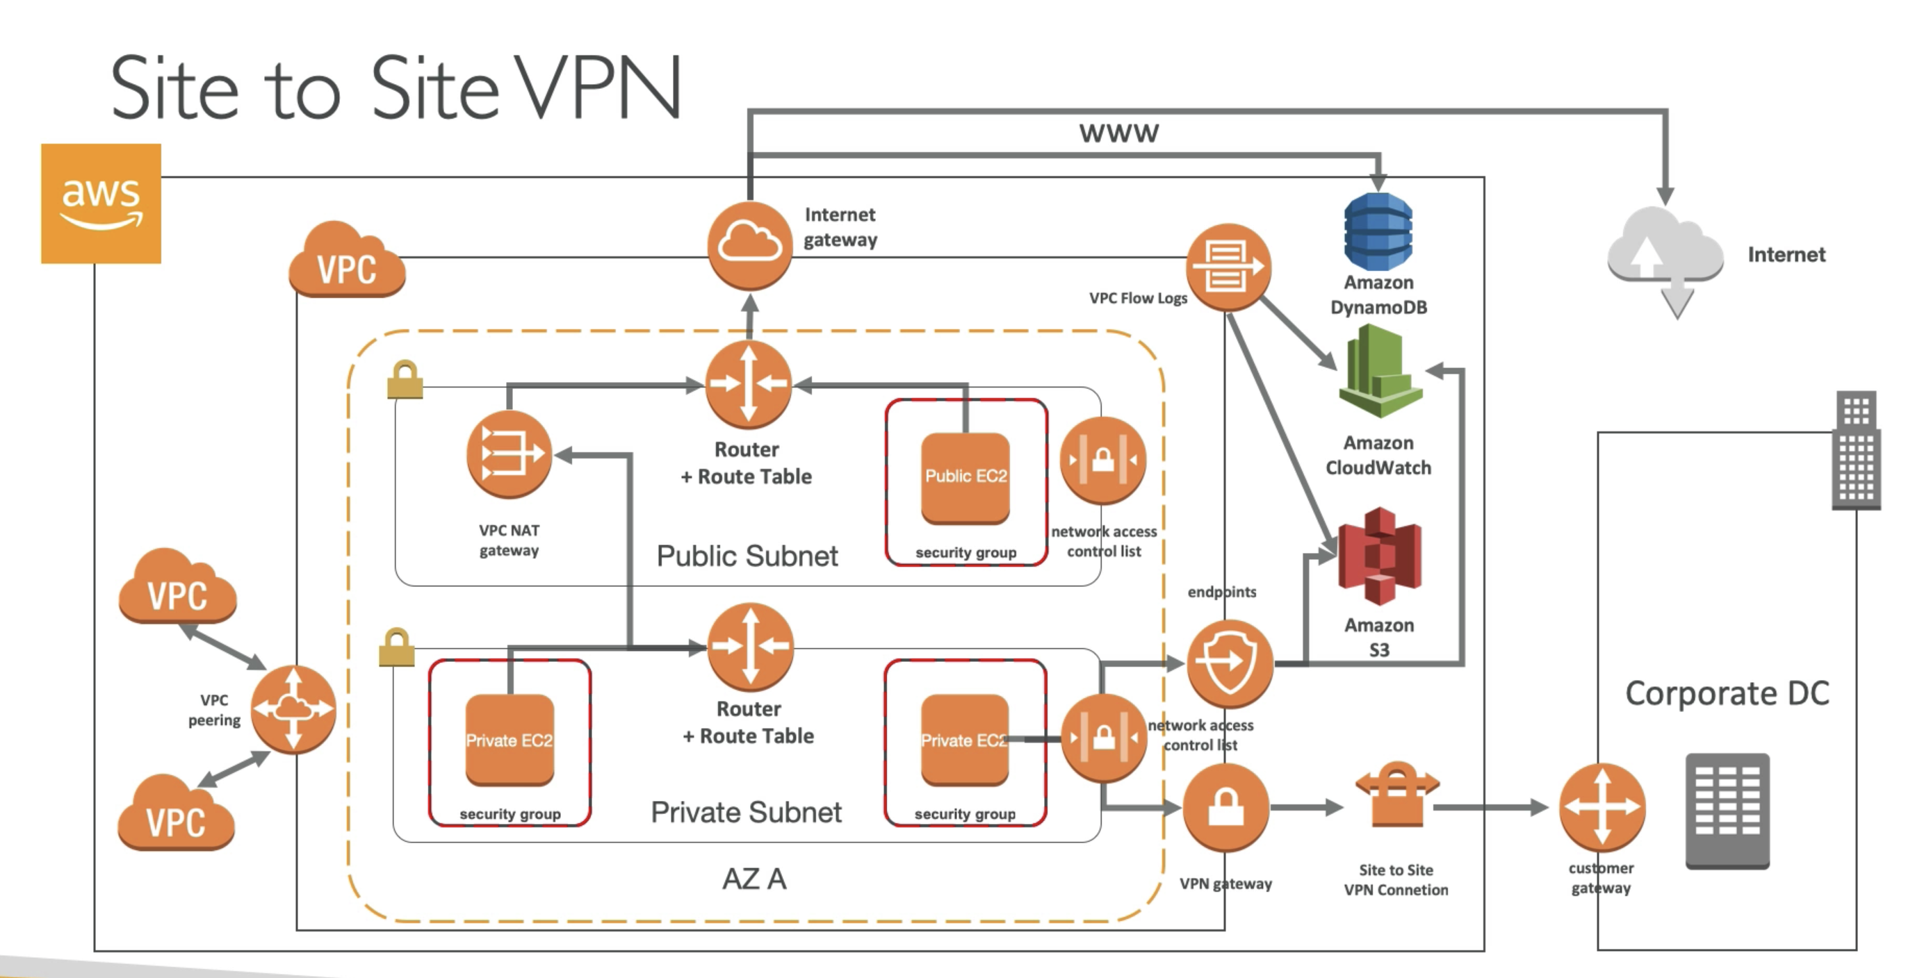

* Customer Gateway is on the Corporate DC side
* VPN Gateway is in the AWS side
* Site to Site VPN will establish the connection between Customer Gateway and VPN Gateway

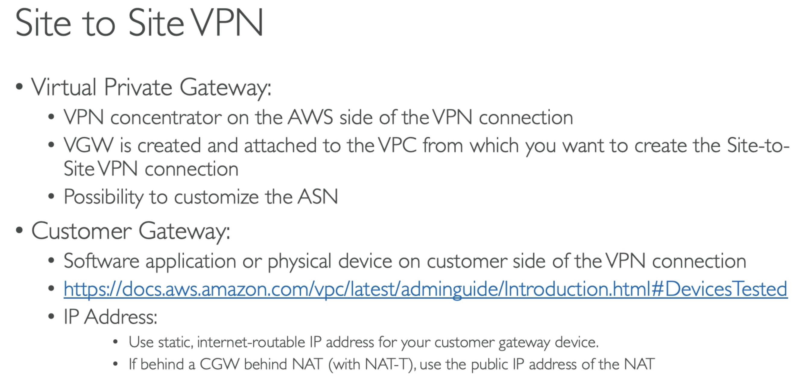

ExamTip: if there is a NAT installed at the customer side, use the public IP address of that NAT instance.

# 252. Direct Connect and Direct Connect Gateway

* In case of Site to Site VPN… the traffic will flow through internet from Customer DC to AWS.
* Direct Connect provides a private connection between the two. We need to physically establish a connection between customer location and direct connect network.

## Direct Connect

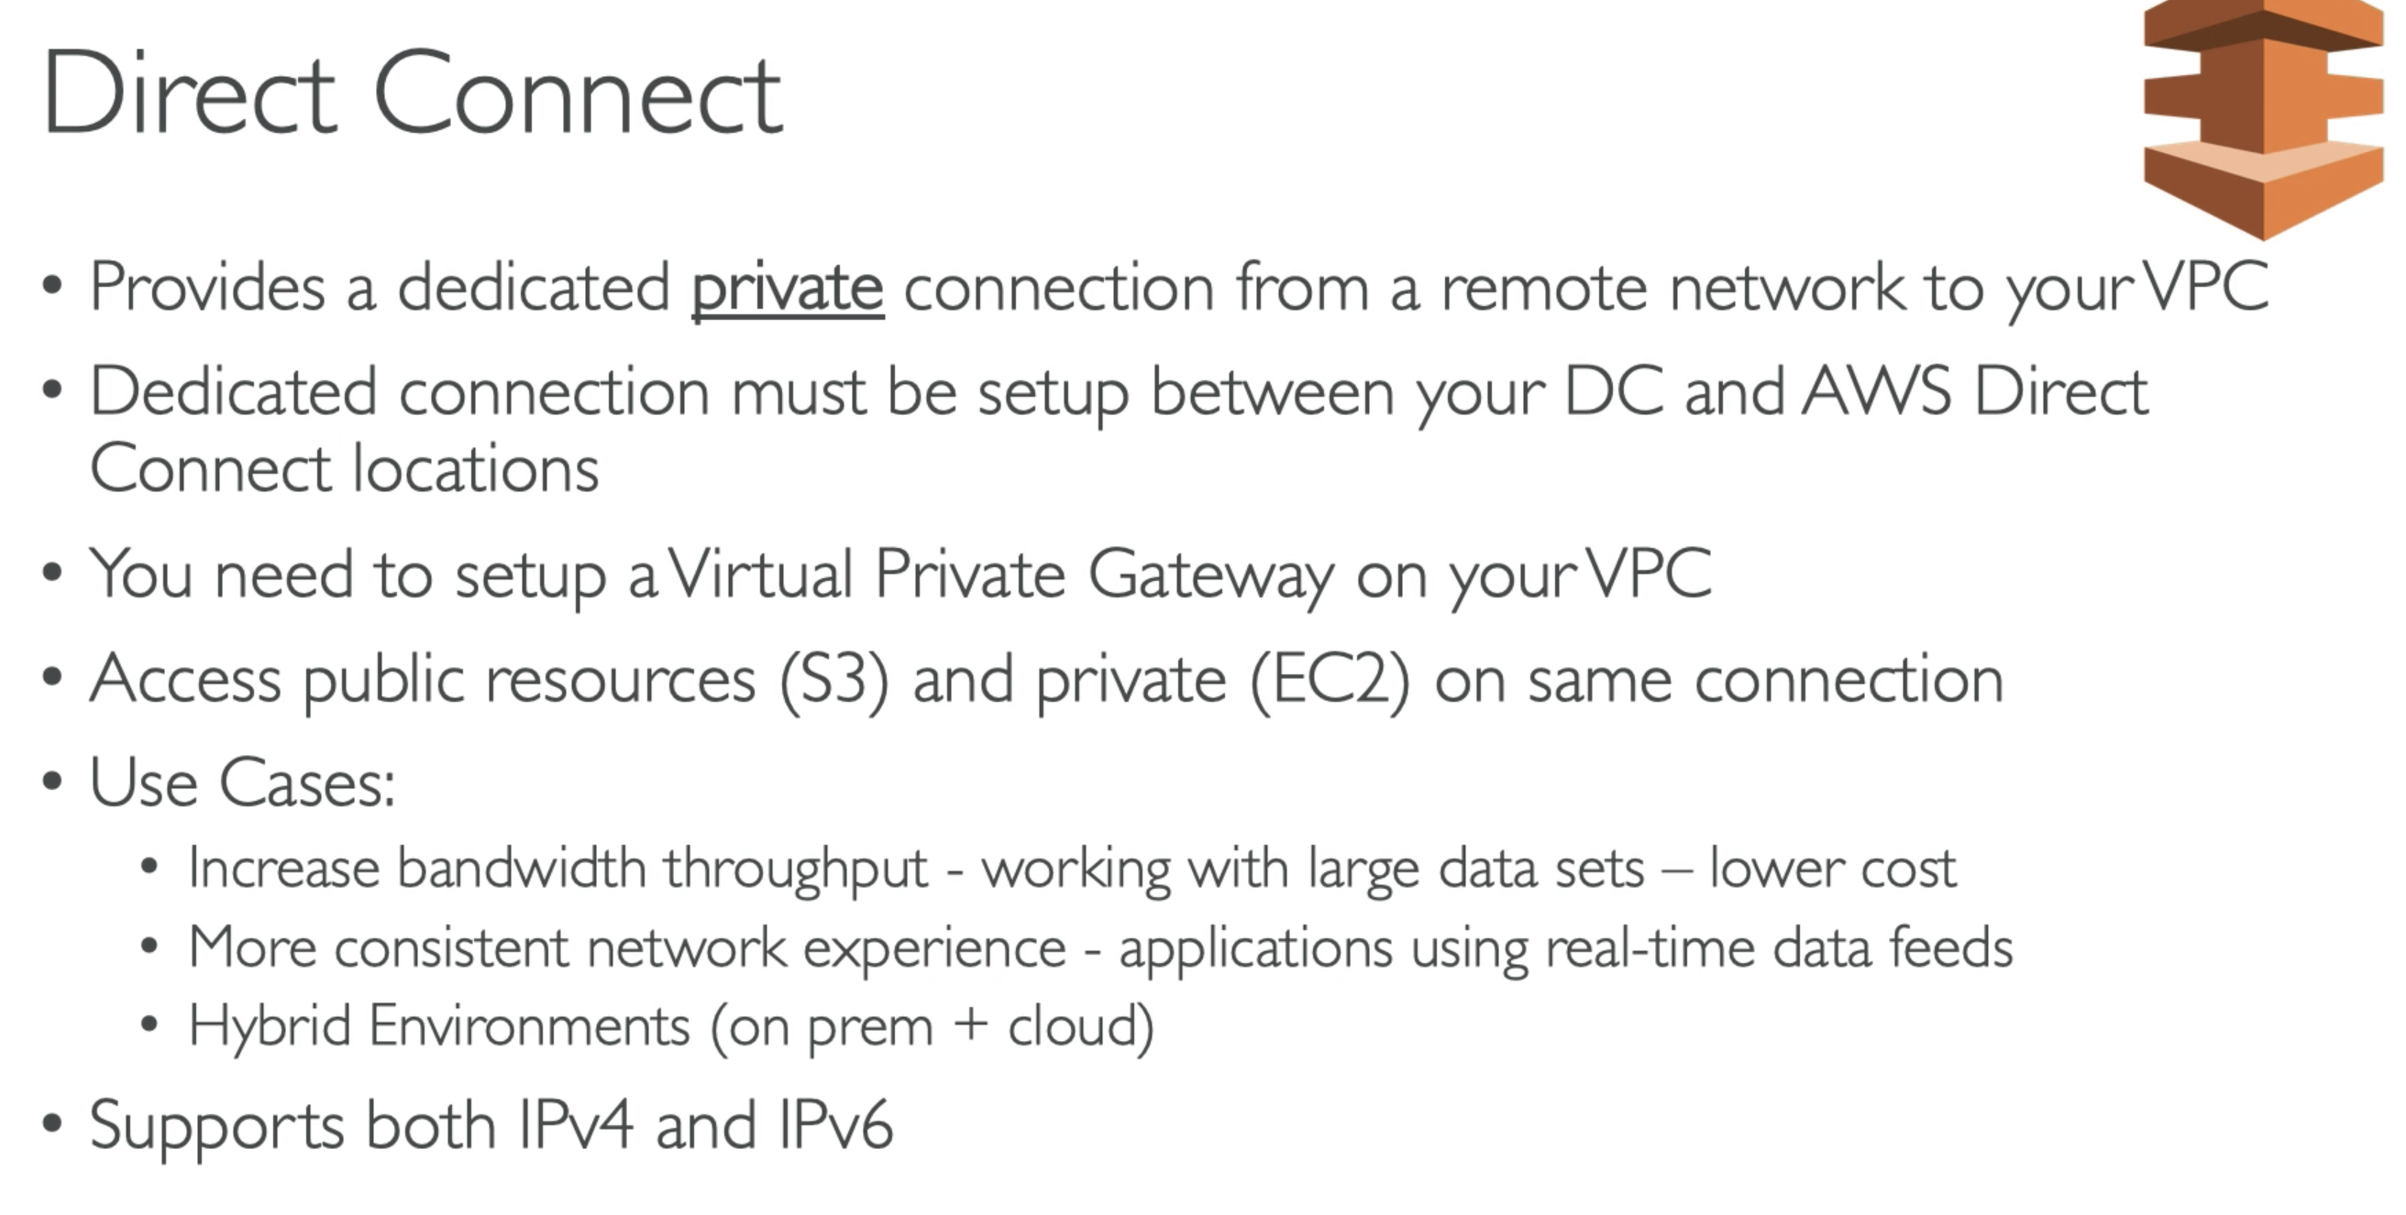

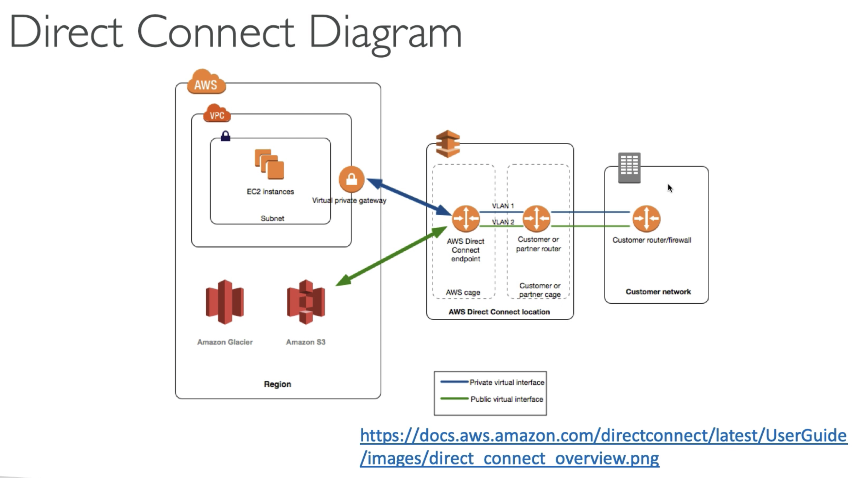

## Direct Connect Gateway

* In case you want to connect to multiple VPC, use Direct connect Gateway.
* The VPC’s must not have overlapping CIDR
* This is not replacing a peering connection… means

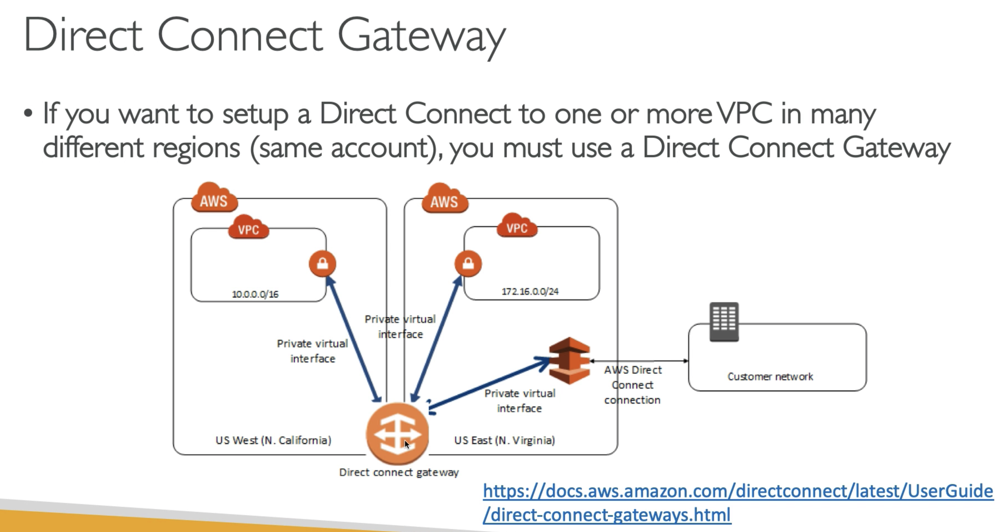

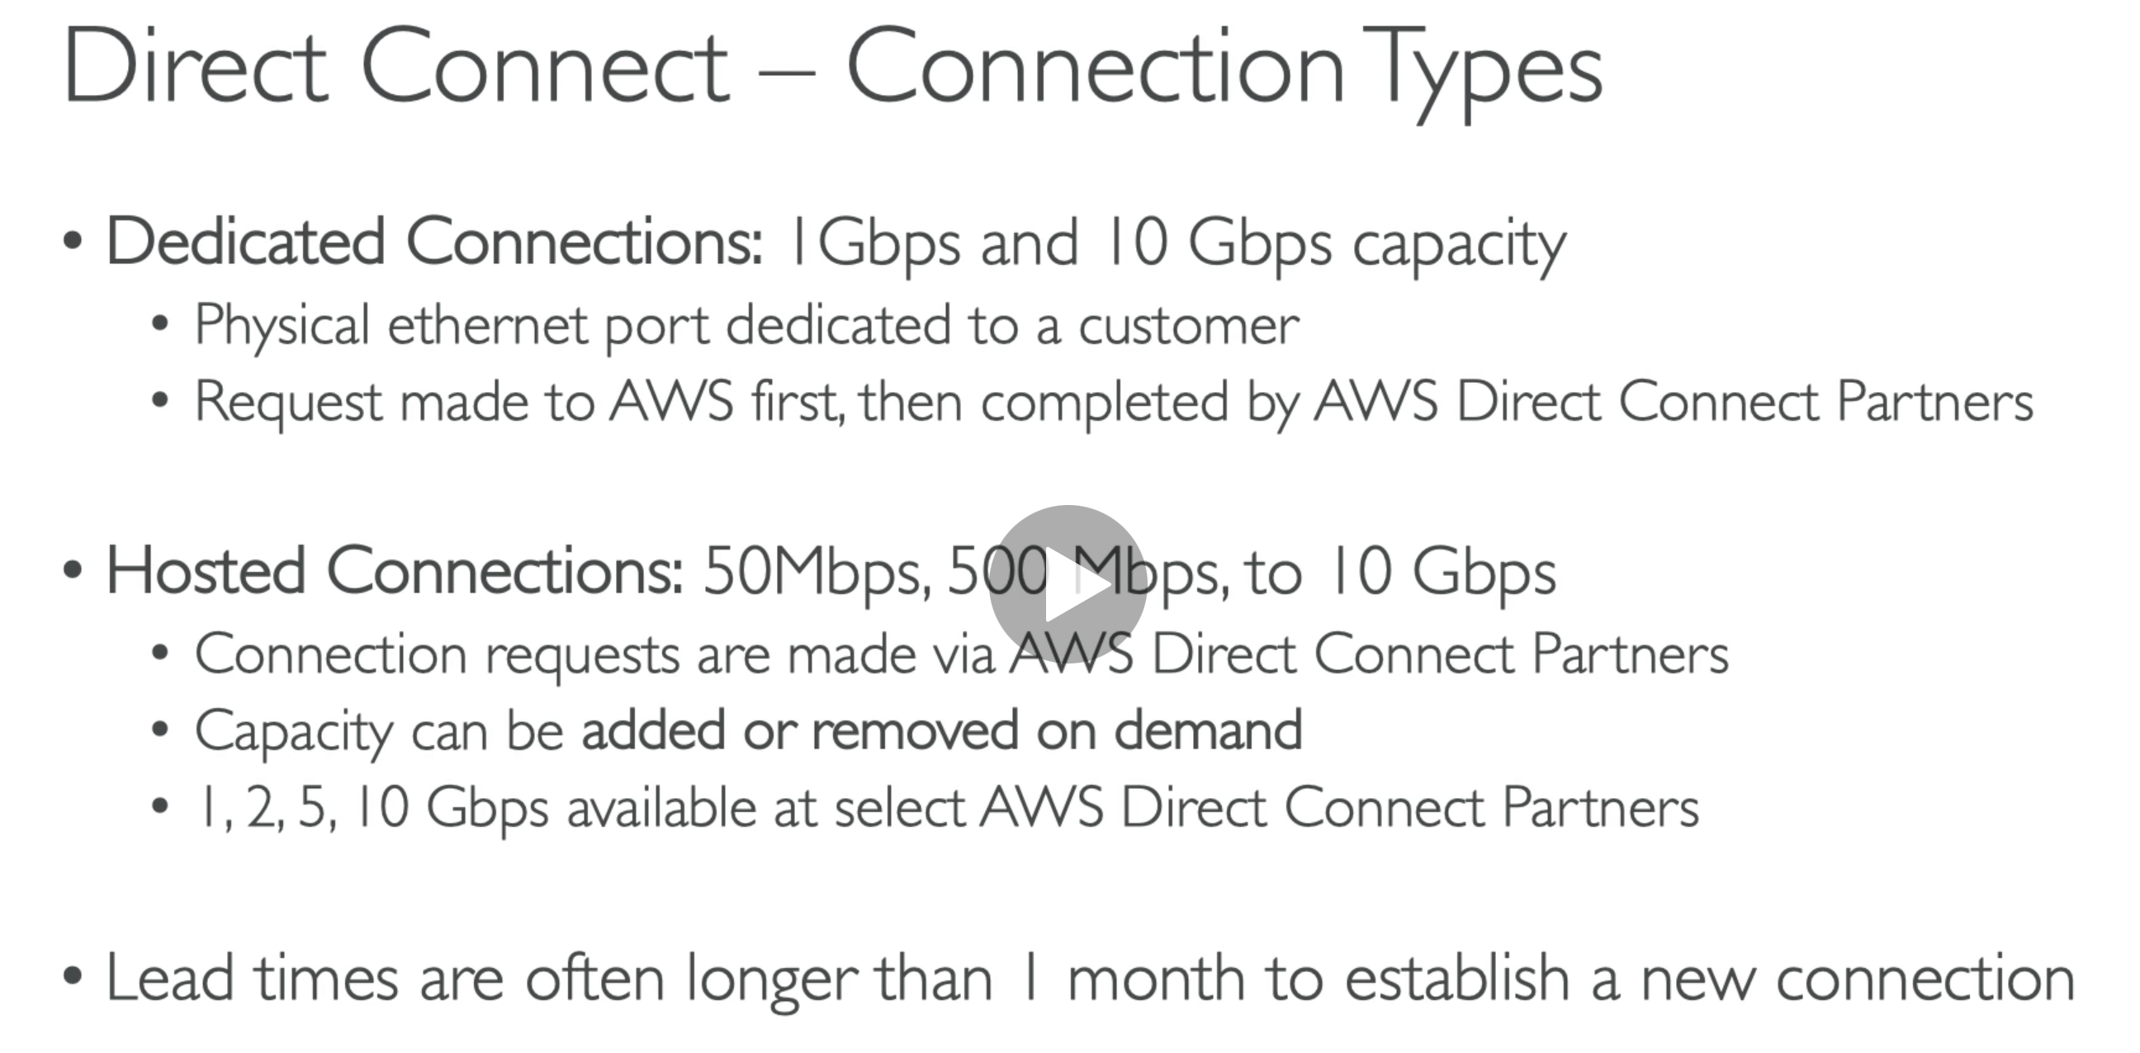

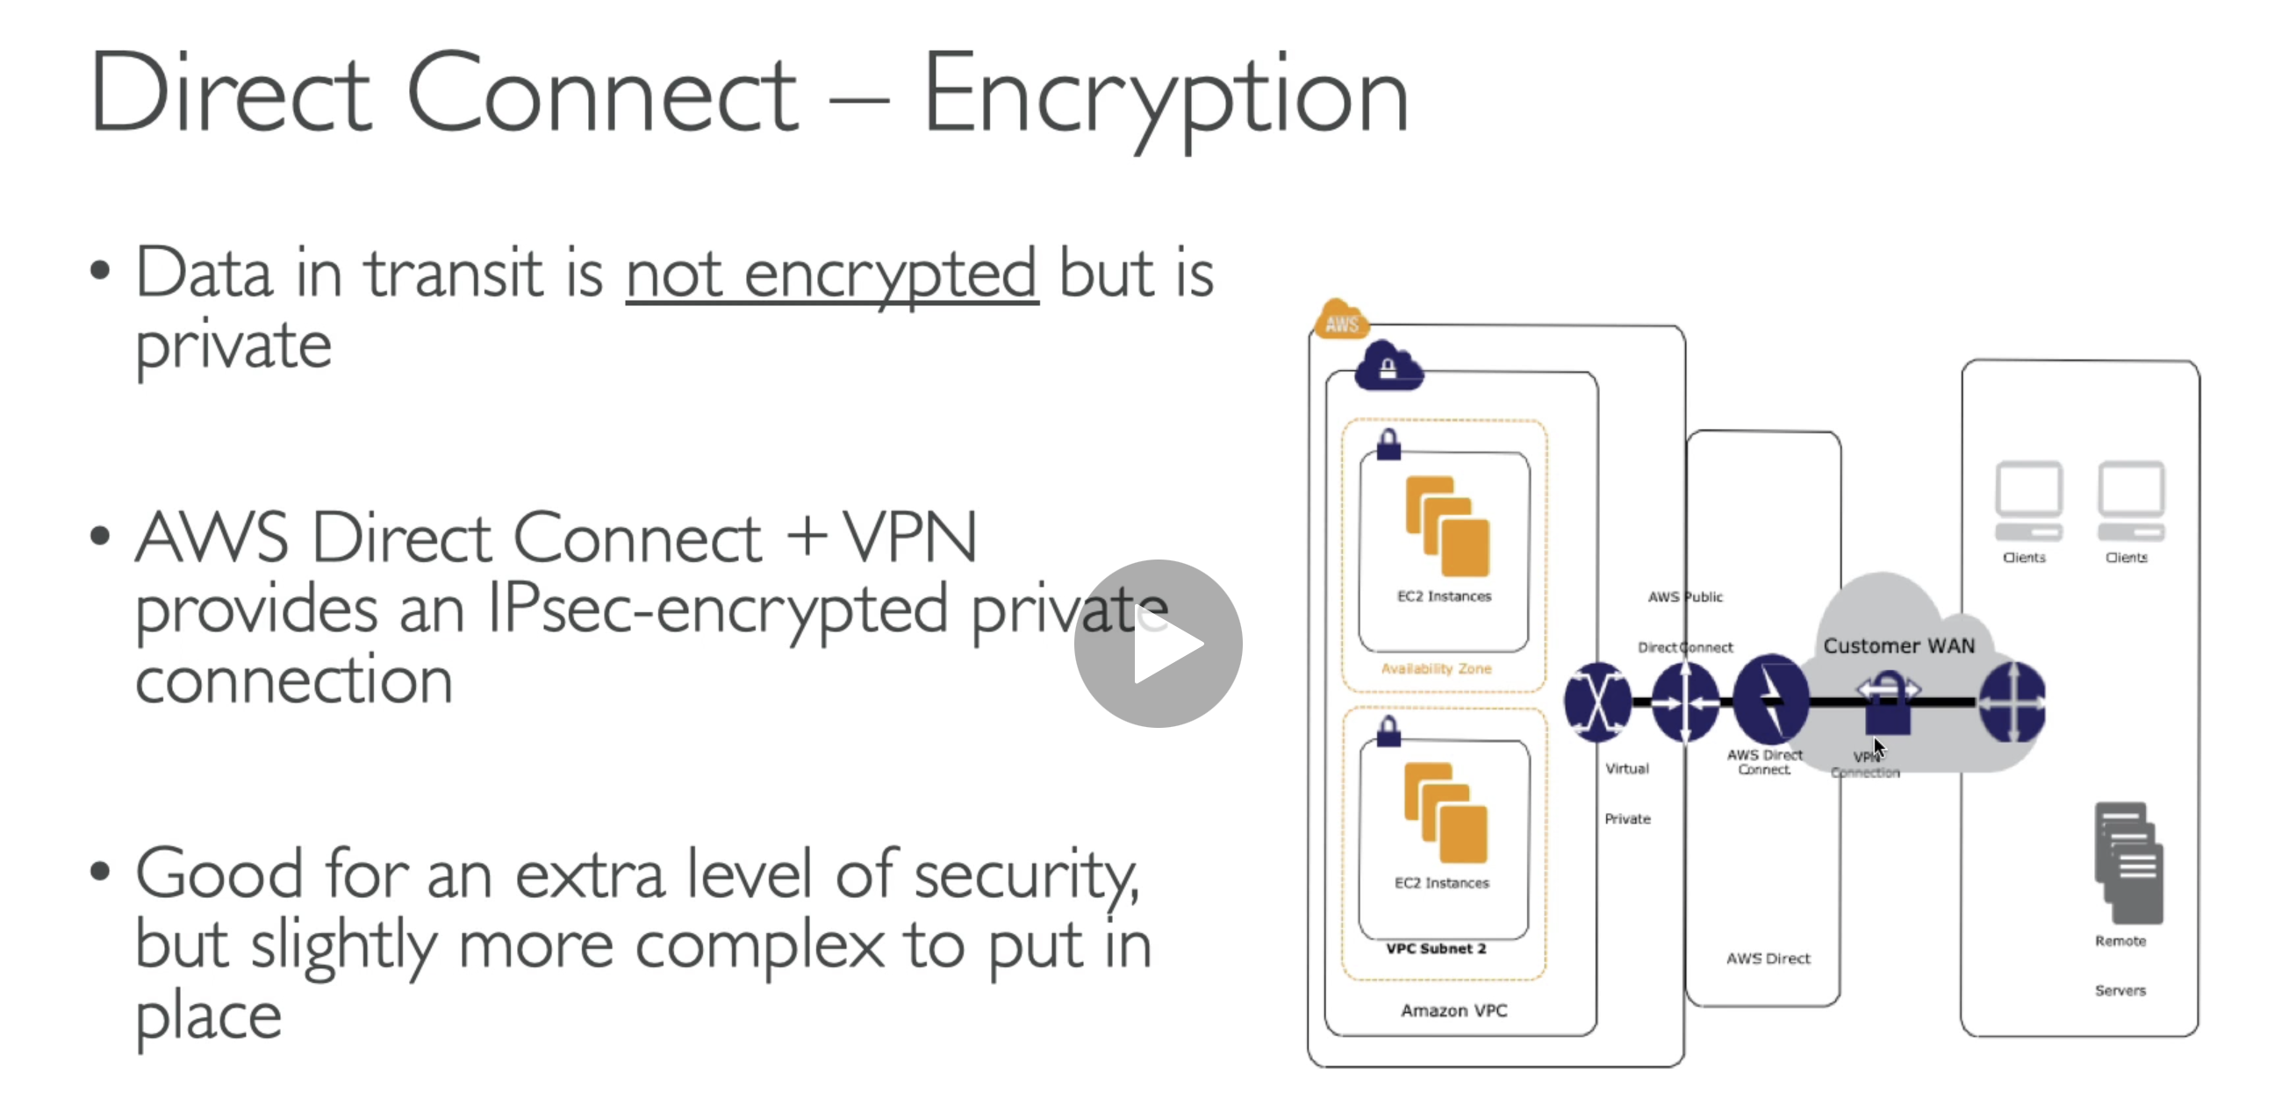

# 253. Egress Only Internet Gateway

* NAT allowed our private instances that had a IPv4 to access the internet.
* Similarly Egress Only gateway will allow IPv6 instances to access the internet but not being accessible.

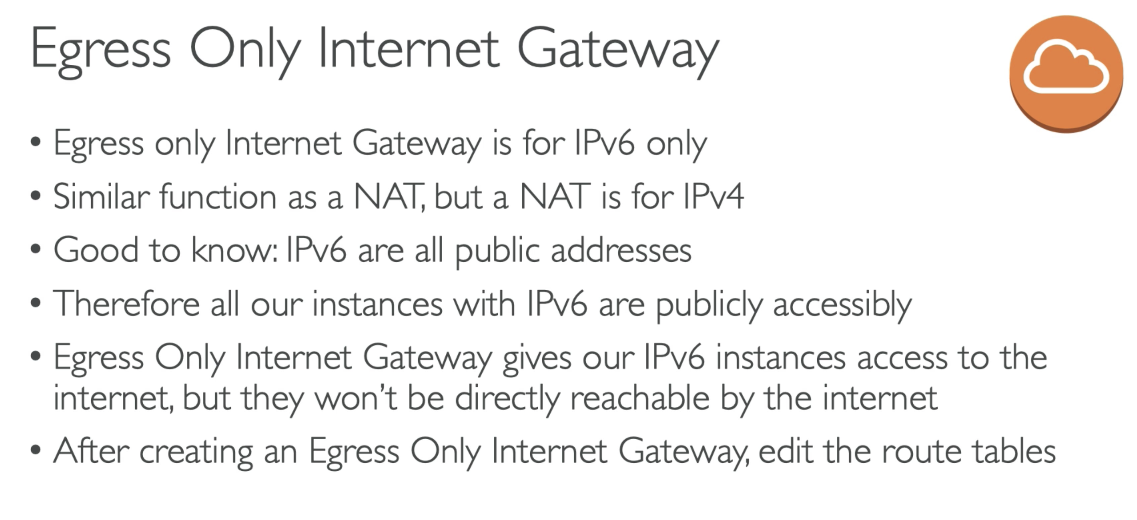

# 254. AWS Private Link – VPC Endpoint service

Problem Statement:

You have VPC in your account, and we have a service application in it.

We want to expose that application to some other VPC in some other account.

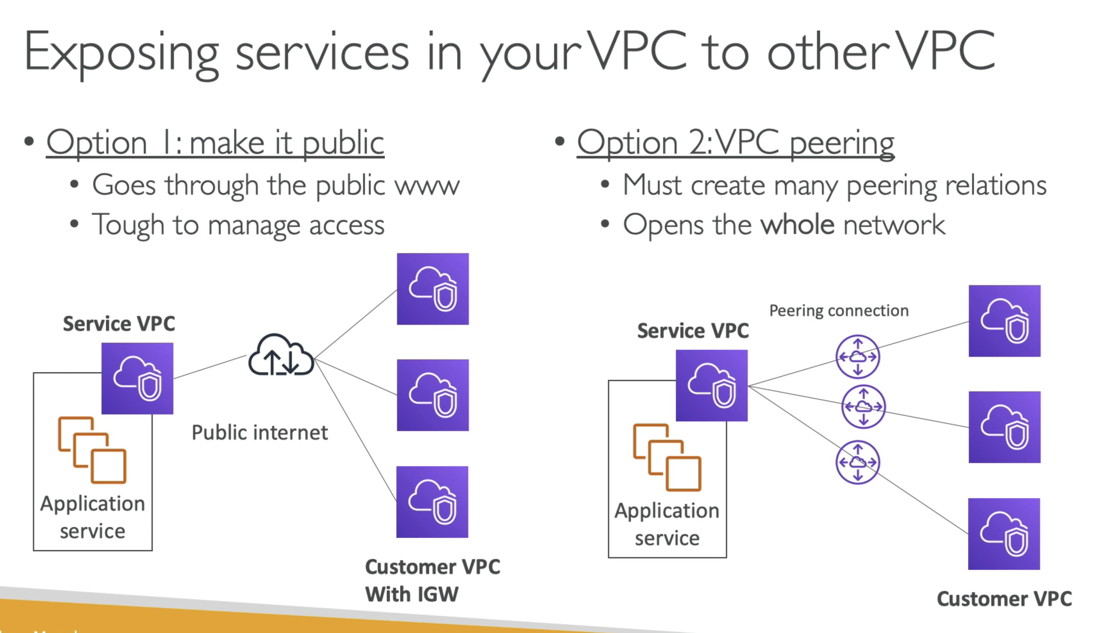

Option 1: traffic flows through internet

Option 2: not just one application, but all the apps in our VPC will be accessible to all other VPC through the peering connection.

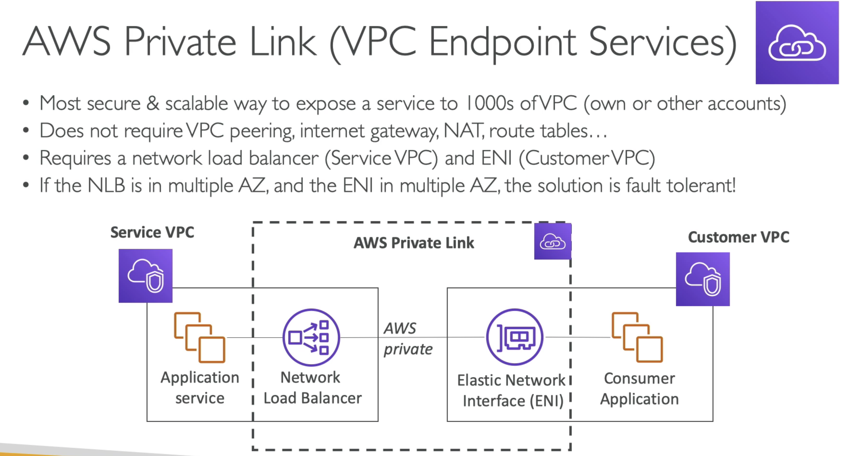

### ExamTip:

Q: if you have to expose your application to 100 other VPC

The choice is 🡪 Private Link

# 255. AWS Classic Link

AWS Classic and Classic Link both are deprecated by AWS.

If you see this in exam, most likely it is a distractor.

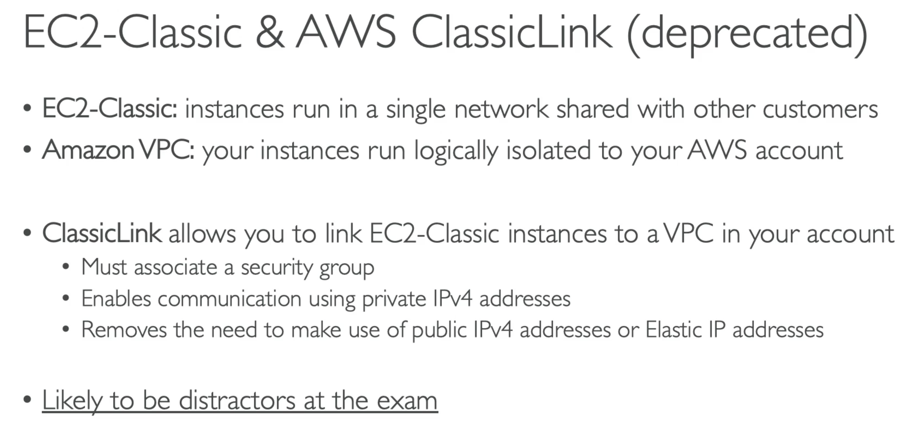

# 256. VPN CloudHub

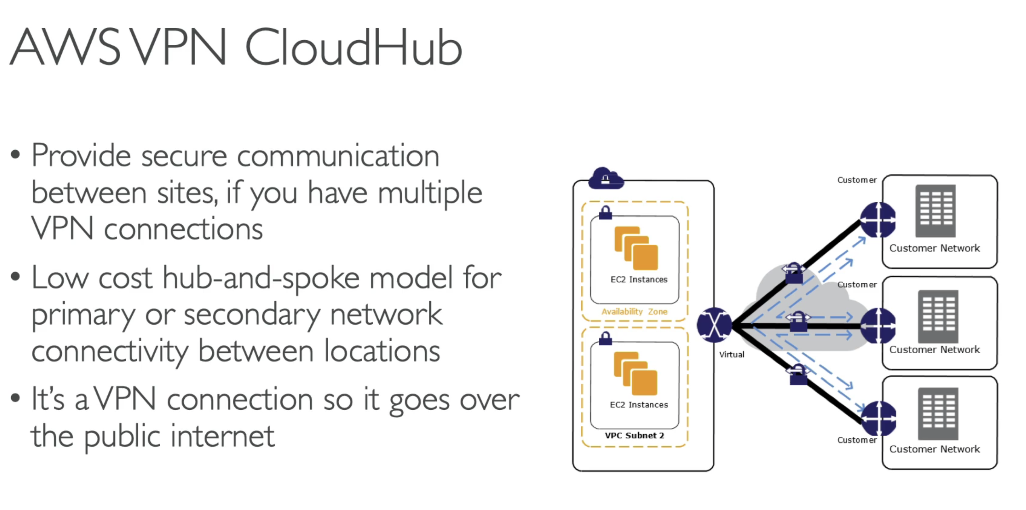

# 257. Transit Gateway

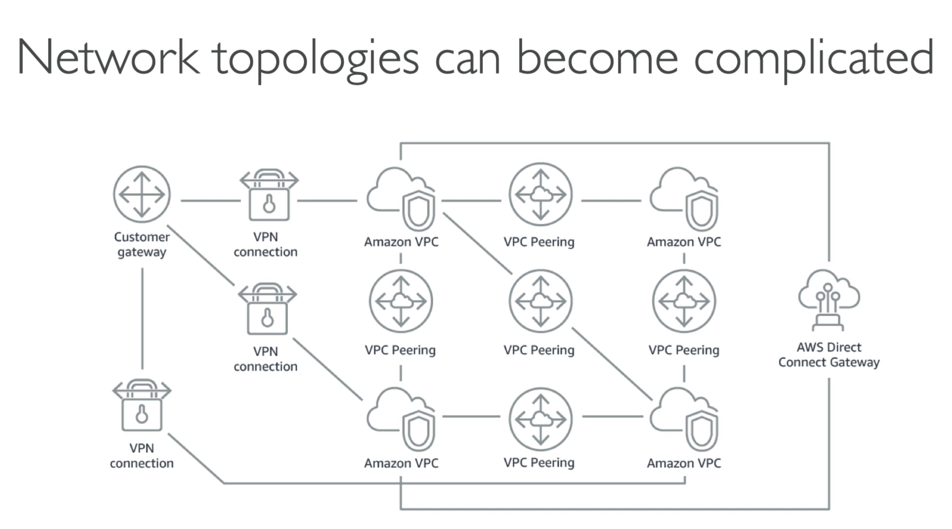

Transit Gateway creates a star network, through which all the VPC’s can talk to each other and the network topology is not too messy.   
We cannot share transit gateway through multiple accounts.

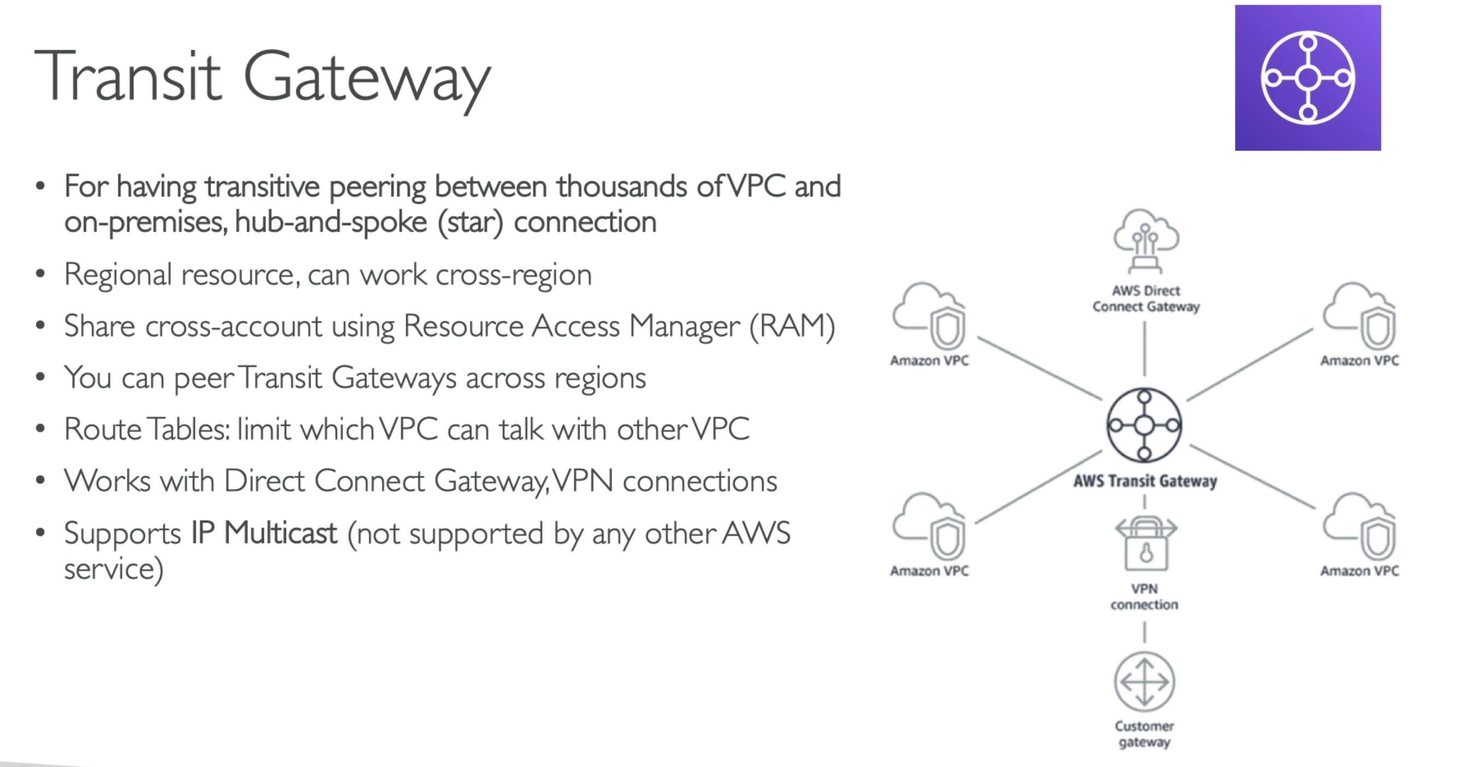

### ExamTip:

### If you see support for Multicast 🡪 think of Transit Gateway

# 258. VPC Section Summary

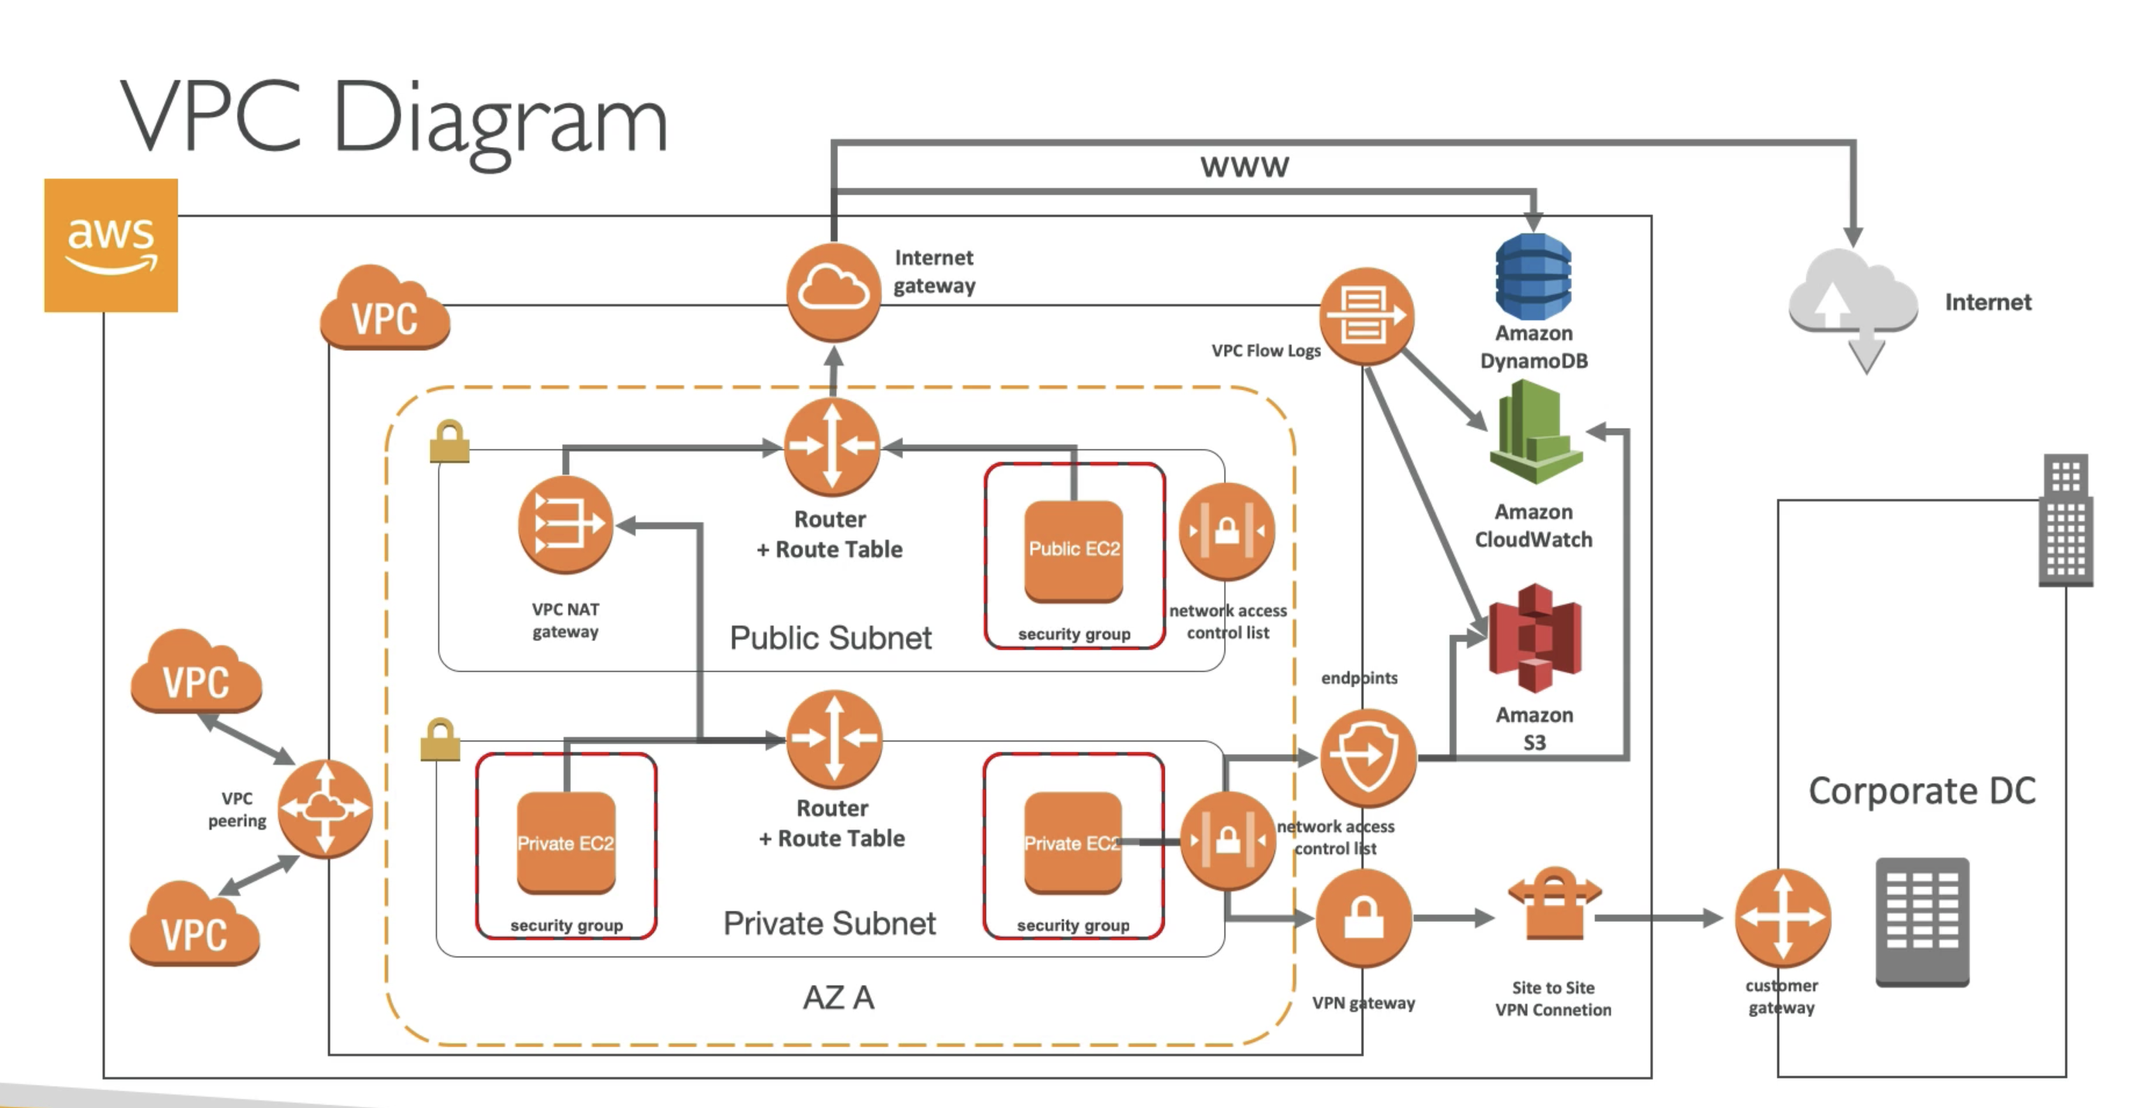

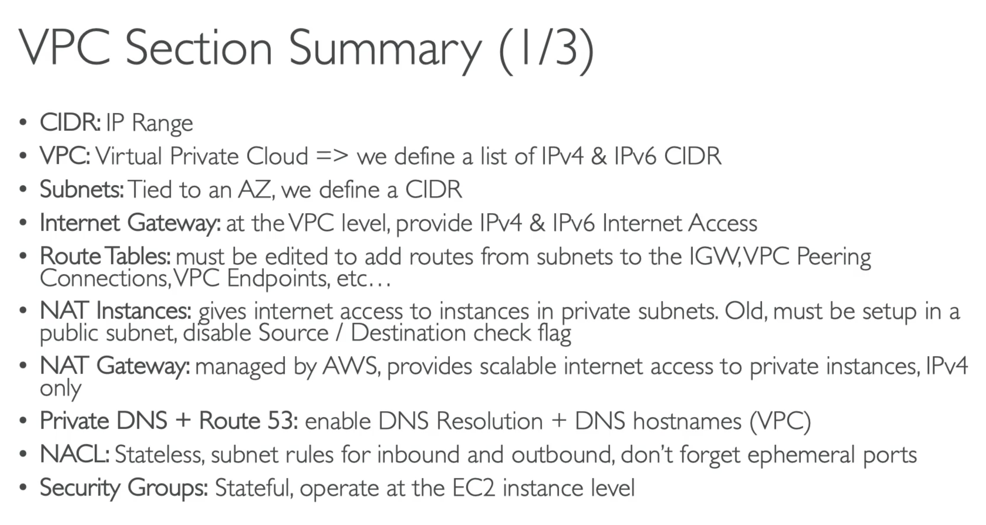

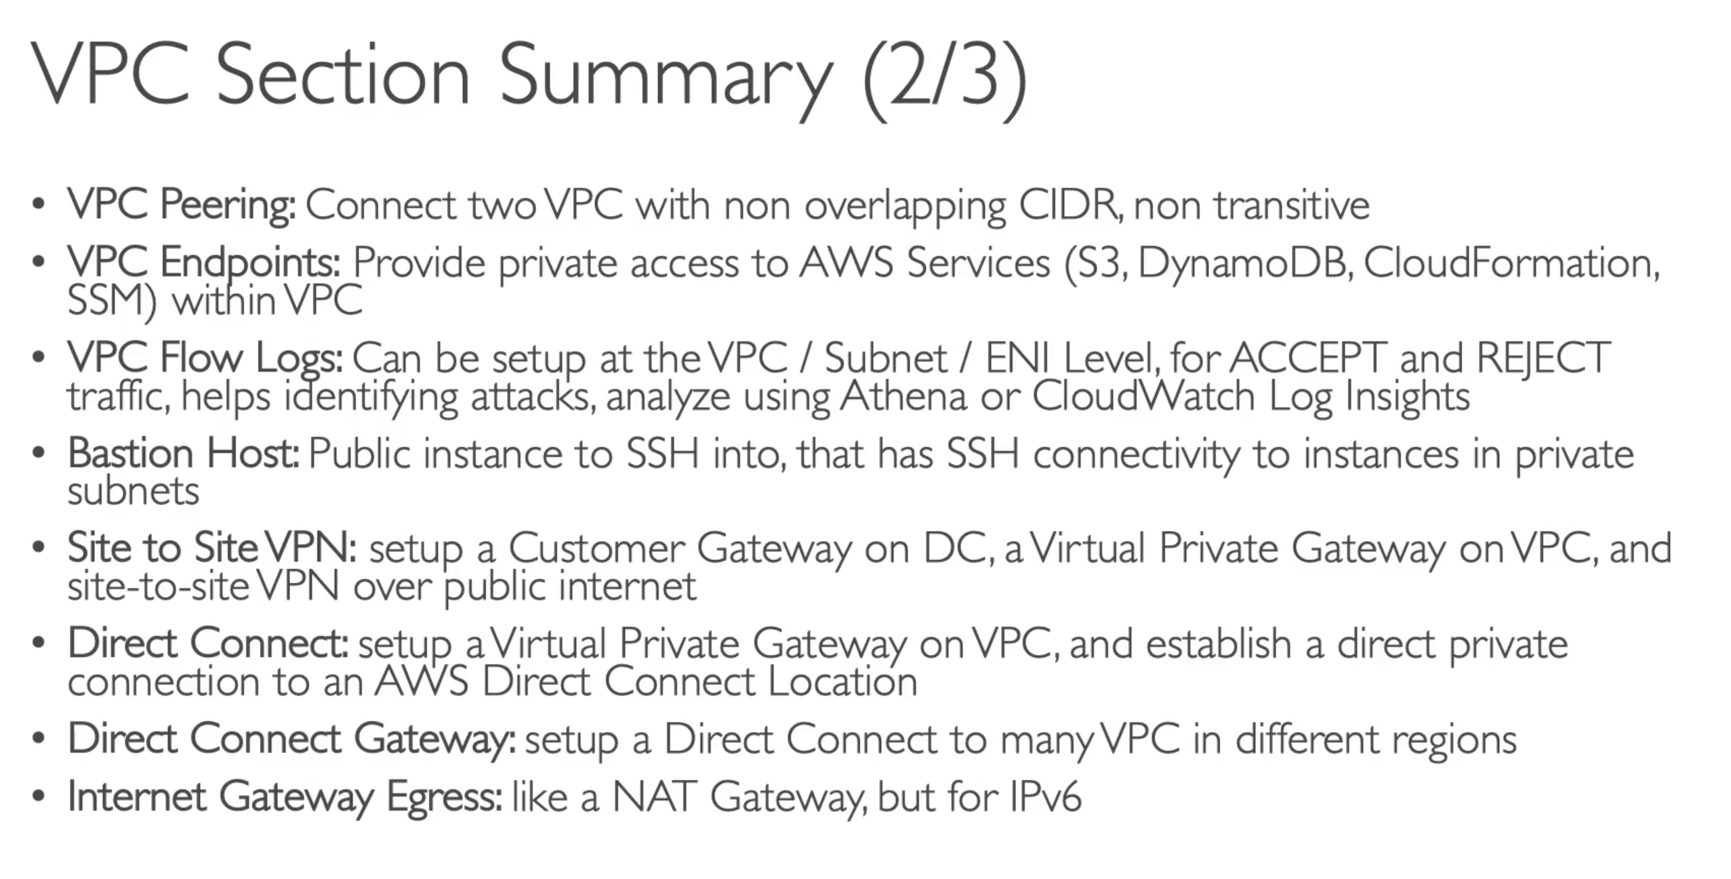

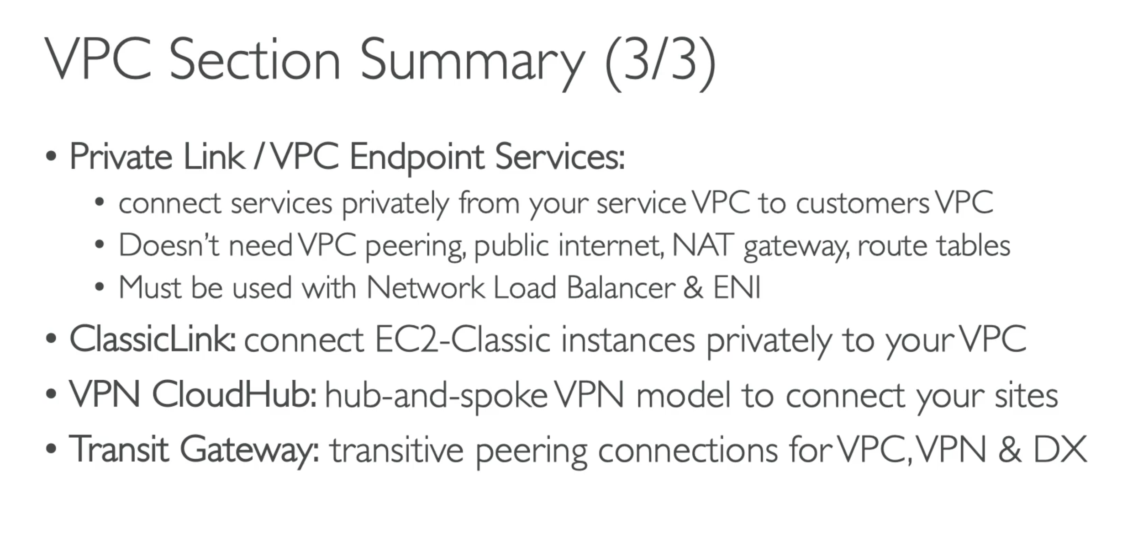

# 260. Networking Costs in AWS

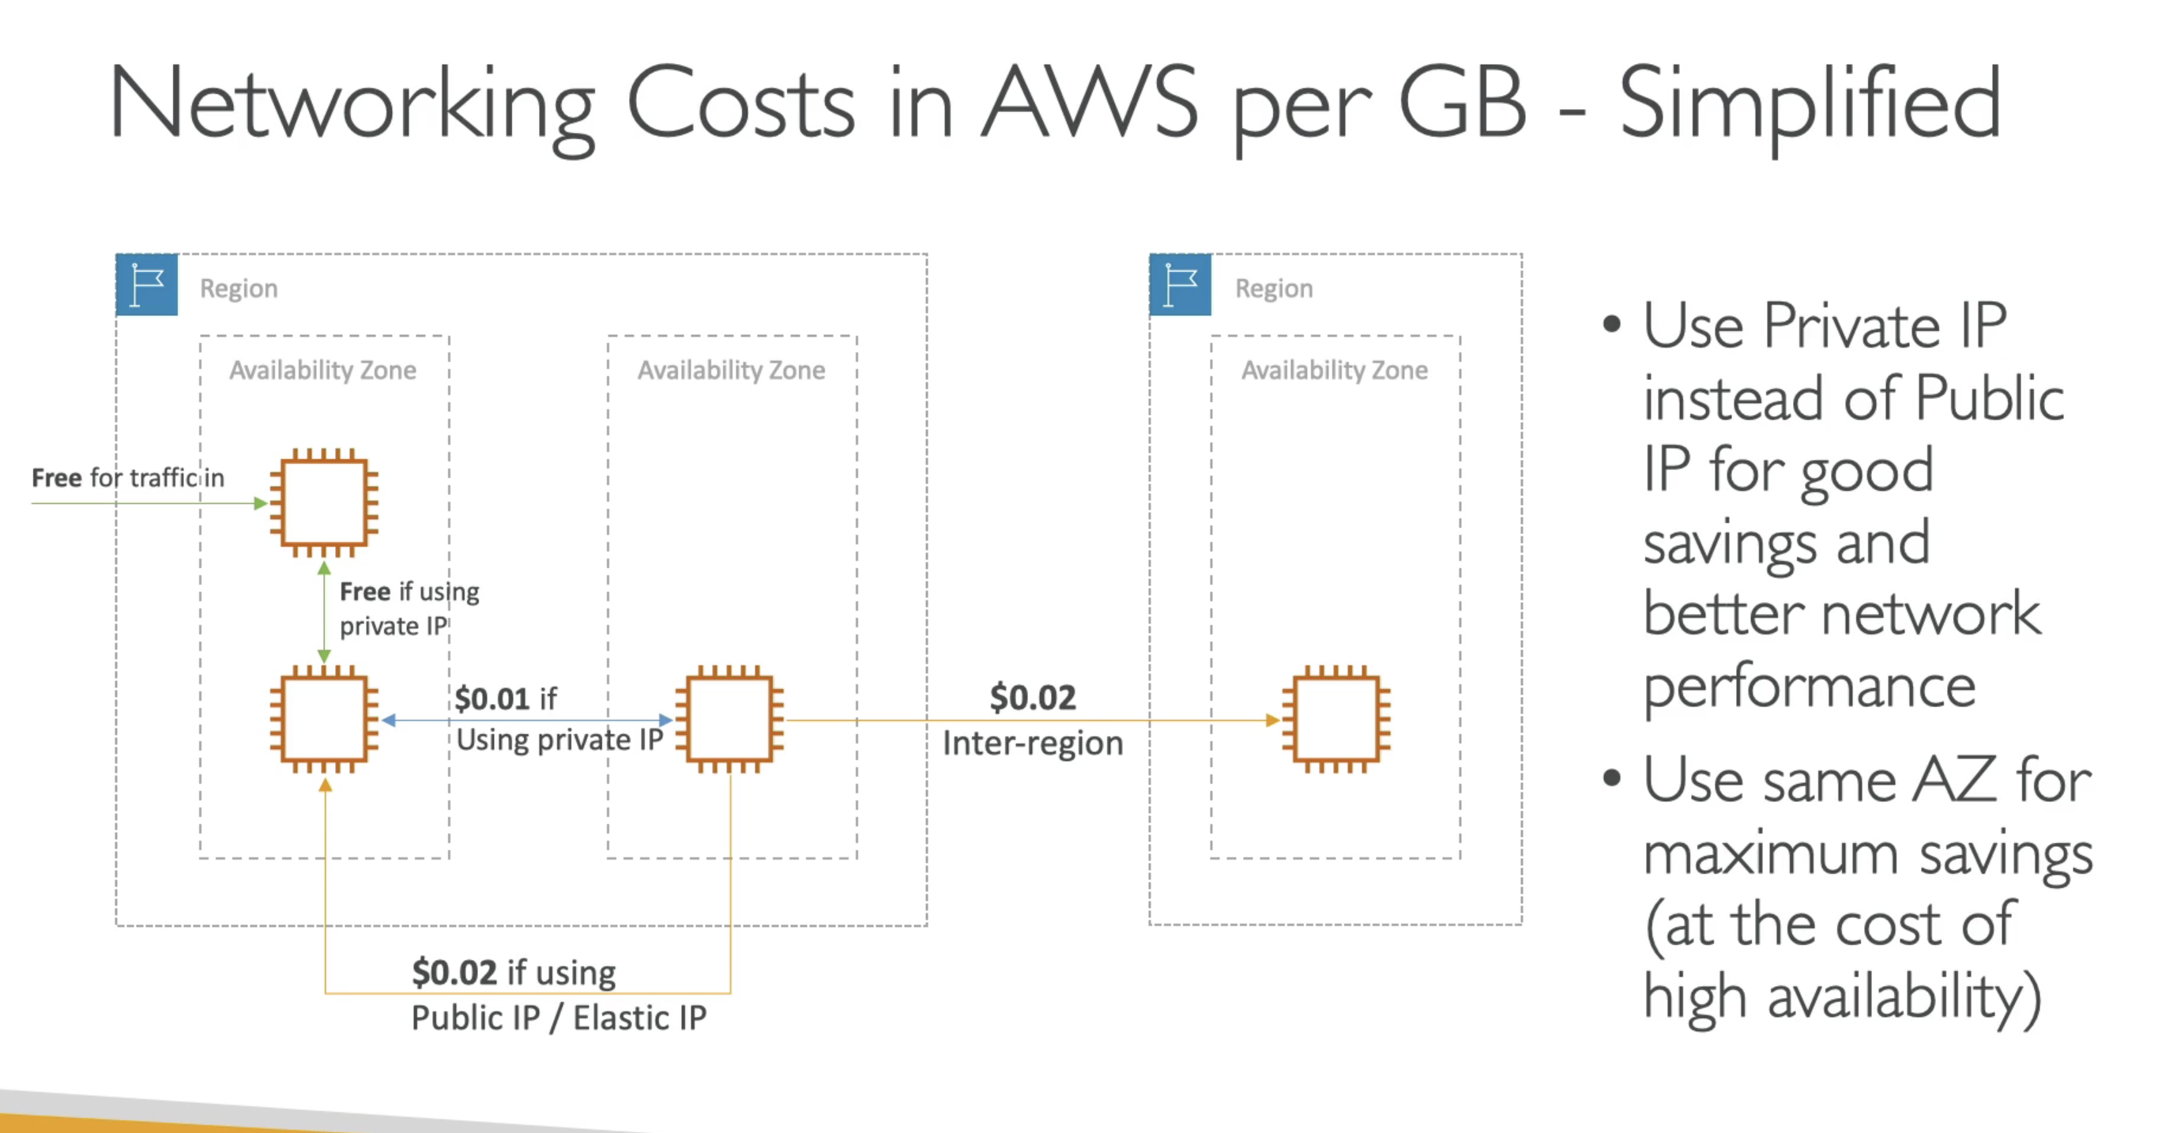

* Any incoming traffic into the EC2 instances are free
* Any traffic between two EC2 instances are free, assuming they are using their private IP to communicate
* Two instance in two AZ, within same region –
  + $0.02 if using public IP or Elastic IP, because the traffic will go out of the AWS network
  + $0.01 id using private IP

Note: if you want your instances to communicate faster and lesser priced … try to be on private network as much as possible

* Inter-region 🡪 $0.02/GB

**Example Qn**: We have a RDS database, we want to create a read replica and do some analytics on top on the read replica. How do we create the Read Replica with the cheapest amount money?

**Ans**:

* If you create the Read replica in the same AZ, then you will not be charged for copying database to another in terms of network cost,
* If you create the read replica in another AZ within the same region, then you pay $0.01/GB for data transfer.